 | 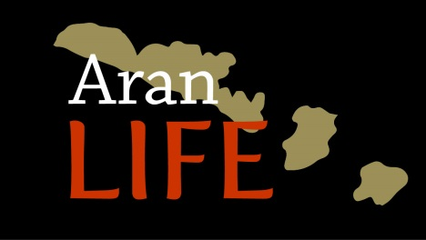 | 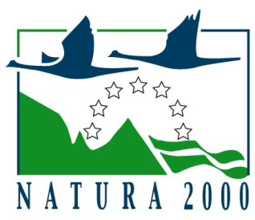

7.2.10 Ecosystem functions restoration resulting from the project actions I -Optimal Grazing Scores

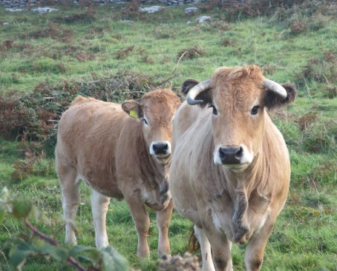

December 2018

Contents
Introduction 3
The biodiversity of the farmed landscape of Aran Islands 3
The habitats 4
Botanical diversity 5
Conservation of genetic diversity 7
Butterfly diversity dependent on the farmed habitats 7
Avian fauna dependent on the farmed habitats 8
Other important species dependent on the biodiversity 9
Optimal grazing score system 10
Methodology 14
Grazing score analysis 14
Grazing score verification 14
Results and Discussion 16
Comparison of field scores from 2014 and 2016 16
Year 1 vs year 3 scores 16
Grazing score change on Islands 18
Total species diversity 20
High quality, positive and negative Indicator species 22
Indicator species analysis 27
Classification of vegetation in each of the grazing scores – ERICA 28
Hierarchy of Grassland Community Classification 28
Grazing scores and Vegetation types. 30
Conclusions 32
References 33

Introduction
The Aran Islands are an agricultural landscape which has developed over the years for the production of food to support the inhabitants and for export to the mainland. A combination of the environment and the extensive farming system practiced on the three Aran Islands created a mosaic of habitat types which support a wide range of flora and fauna. It is now widely recognised that such farmed landscapes, dominated by semi-natural pastures, deliver a range of other services other than food production.
Ecosystem services are the set of ecosystem functions that are useful to humans. These services make the planet inhabitable by supplying and purifying the air we breathe and the water we drink. Water, carbon, nitrogen, phosphorus, and sulfur are the major global biogeochemical cycles. Disruptions of these cycles can lead to floods, droughts, climate change, pollution, acid rain, and many other environmental problems. Soils provide critical ecosystem services, especially for sustaining ecosystems and growing food crops, but soil erosion and degradation are serious problems worldwide. Higher biodiversity usually increases ecosystem efficiency and productivity, stabilizes overall ecosystem functioning, and makes ecosystems more resistant to perturbations. Mobile linked animal species provide critical ecosystem functions and increase ecosystem resilience by connecting habitats and ecosystems through their movements. Their services include pollination, seed dispersal, nutrient deposition, pest control, and scavenging (Sekercioglu 2010).
These ecosystem services are the conditions and processes through which natural ecosystems, and the species that make them up, sustain and fulfil human life (Daily 1997). They maintain biodiversity and the production of ecosystem goods. The ecosystem goods (such as food) and services (such as waste assimilation) represent the benefits human populations derive, directly or indirectly, from ecosystem functions (Costanza et al. 1997).
Within the ecosystem services provided by European agriculture, the conservation of biodiversity and agricultural landscapes are predominant but also include other services for society, such as carbon storage, clean water, wildfire prevention and storage of genetic diversity.
This report illustrates how the project actions impact on the ecosystem function of biodiversity through the use of a scoring system which is based on the diversity of a particular set of indicator species.

The biodiversity of the farmed landscape of Aran Islands

Aran Islands are 40km² in area and yet they are home to approximately 500 plant species. This is an amazing statistic considering that this equates to nearly half the total number of species within the whole island of Ireland and even more amazing when you consider that there are no bogs, mountains, rivers and woodlands on the Aran Islands that could contribute to this incredible species diversity. To give an idea of the amount of species that can be found in a small area, the AranLIFE team have recorded 46 different plant species in a 4m² area.

The habitats
The main habitat with this incredible biodiversity is grasslands, man-made grasslands for the most part that have been managed from generation to generation through low-intensity farming methods. The traditional farming system of Winterages, conserves and enhances the species richness of the grasslands as through this system the fields are grazed throughout the winter, which produces a short turf grassland which in the springtime, herbs such as spring gentian, bloody cranes bill, birds foot trefoil and lady’s bedstraw flower (Fig. 1) and fill the fields full of colour, and then set seed, free from grazing in the summer months (Fig. 2). In this way the seed bank and species-richness of the fields is conserved and enhanced. The limestone pavement in the Winterages act like storage heaters, warming up in the summer months and releasing their warmth throughout the winter, and the lack of frost and dry, well-drained fields make the islands ideally suited to this farming system (Fig. 2).
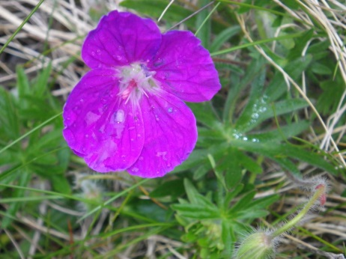 | 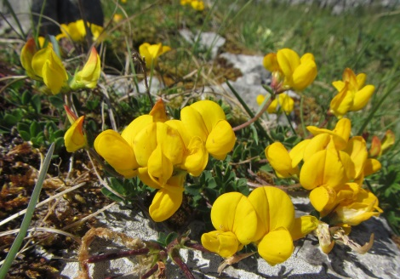 | 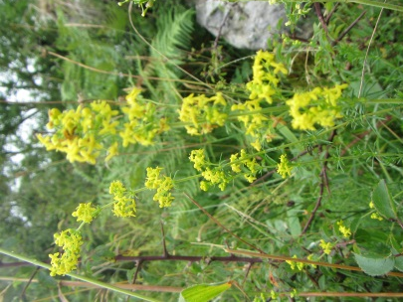
Fig. 1. Bloody cranesbill, birds-foot-trefoil and Lady’s bedstraw fill the winterage fields with colour during the summer
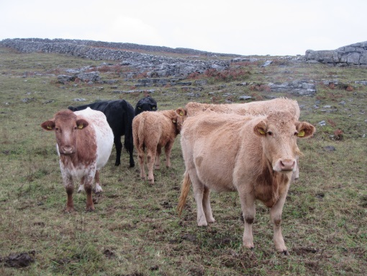 | 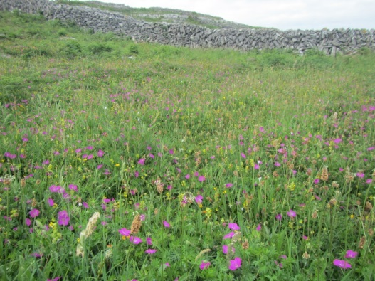
Fig 2. The fields are grazed in winter allowing herbs to flower and set seed in the spring and summer.
These farmed habitats are internationally important for nature conservation and are designated as Priority Habitats in the EU Habitats Directive, namely Orchid-rich calcareous grassland (*6210), Limestone pavement (*8240) and Machair (*21A0). Approximately 75% of the islands are designated as Special Areas of Conservation because of these species-rich farmed priority habitats (Fig. 3).
Nationally, Orchid-rich calcareous grassland (Fig 3) is under threat due to habitat loss and fragmentation along with agricultural intensification and succession to scrub following abandonment. The main strongholds for orchid-rich calcareous grassland are the Burren and Aran Islands and Dartry Mountains in Counties Leitrim and Sligo
The Burren is also the largest expanse of Limestone pavement in Ireland. Nationally, quarrying, land reclamation, scrub encroachment, invasive non-native species, problematic native species and lack of grazing are the main pressures that impact negatively on limestone pavement habitat.
Machairs are a flat coastal grassland that only occur on the northwest coasts of Ireland and Scotland, the Aran Islands marking the most southerly end of their distribution globally. Threats to machair include disturbance and unsuitable grazing regimes which have compromised the quality of the habitat (NPWS 2013). The main machair sites on the islands are at Kilmurvey and Iararna on Inis Mór and Ceann Gainimh, Inis Meáin.
While the future of these habitats is uncertain on the mainland, the conservation status of these habitats on the islands has improved over the past four years owing to the efforts of the AranLIFE project, with participant farmers removing scrub, building rain catchers and achieving optimal grazing which is vital to maintain these species-rich grasslands.
Orchid-rich grassland | Limestone pavement | Machair
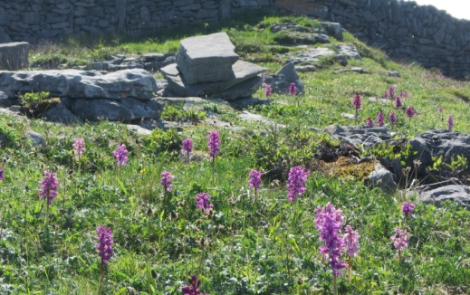 | 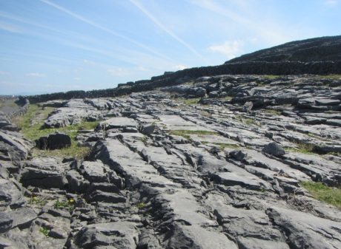 | 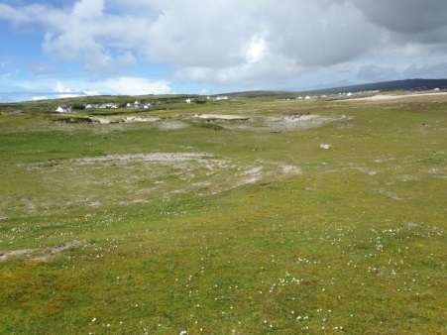
Fig 3. The National Distribution of Orchid-rich calcareous grassland (*6210), Limestone pavement (*8240) and Machair (*21A0)

Botanical diversity
As well as having a huge diversity of plant species here on the islands there are also interesting species here that are frequent on the Islands but that are rare or absent elsewhere.
There are have plants that are at their most northerly limit of their distribution in Ireland, e.g. Dense flowered orchid, bee orchid, wild madder. These plants have a Mediterranean-Atlantic Distribution as they have stations on the west coast of Ireland and then are only recorded in Mediterranean regions of France and Spain (Fig. 5).
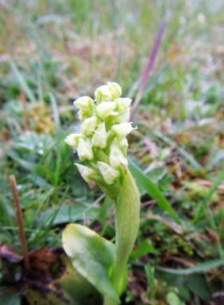 | 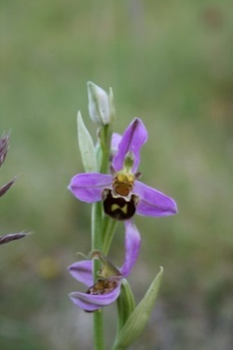 | 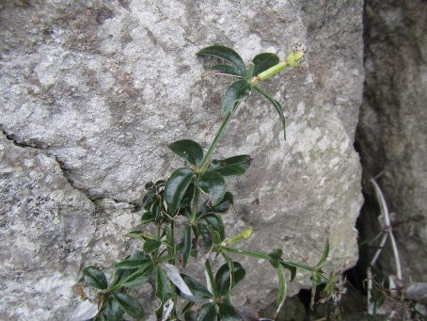
Fig. 4. Plants with a Mediterranean-Atlantic distribution, dense flowered orchid, bee orchid and wild madder.
There are Arctic-Alpine Plants and plants with restricted distribution within Britain and Ireland, e.g. Roseroot, Spring gentian, Salzburg eyebright, Irish saxifrage (Fig. 5). These species are found in the meadows at high altitudes in mainland Europe but occur close to sea level here. Another anomaly of the Aran Island Flora is that these ‘typical’ arctic alpine plants may occur alongside plants typical of Mediterranean regions.
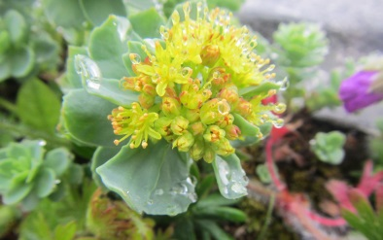 | 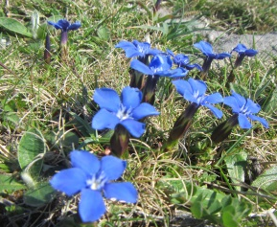 | 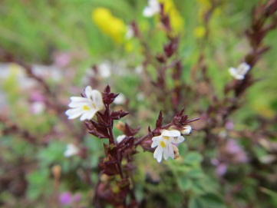 | 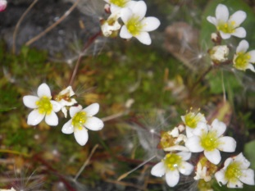
Fig. 5. Aran Island plants that are usually found in alpine meadows at high altitudes in mainland Europe: Roseroot, Spring gentian, Salzburg eyebright and Irish Saxifrage.
There are species with a limited distribution in Ireland and Britain, e.g. Pyramidal bugle, Hoary rock rose, Purple milk vetch, Babingtons leek (Fig. 6). These species occur on the Aran Islands and few other places within the country, for example Purple milk vetch Astragalus danicus only occurs on the Aran Islands within Ireland (Fig 7).
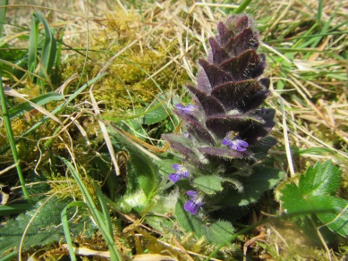 | 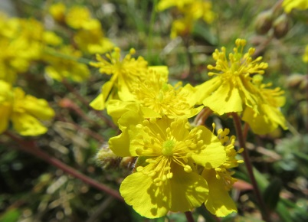 | 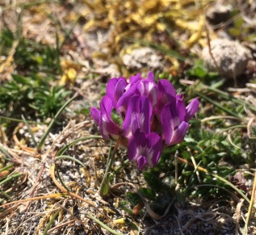 | 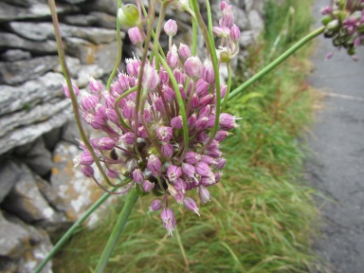
Fig. 6. Species that occur on the Aran Islands but are rare elsewhere: Pyramidal bugle, Hoary rock rose, Purple milk vetch and Babbington’s leek.
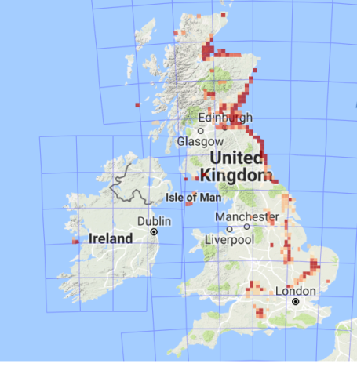
Fig. 7. Distribution map of purple milk vetch Astragalus danicus within Britain and Ireland (http://bsbi.org/maps). The pink and red squares show sites where this species has been recorded, the darker the square the more recent the record. The Aran Islands is the only site for this species in all of Ireland.

Conservation of genetic diversity
On the Aran Islands there are species that have died out elsewhere due to intensification of agricultural practises, e.g., Darnel (Fig.8) This grass species occurs within rye crops on Inis Meáin. This was the only source of seed for Millennium Seed Bank at Kew Gardens, London. The Millennium Seed Bank Seed Collection, is a collection of living seed-plant biodiversity on earth and is a global resource for conservation and sustainable use of plants.
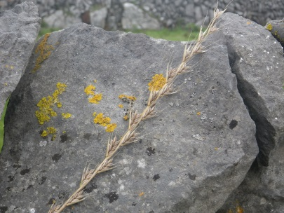 | 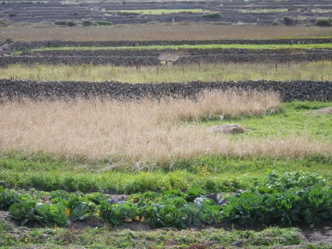 | 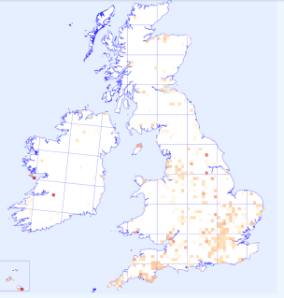
Fig. 8. Darnel (left) which is a rare grass species that occurs within rye crops (mid). Recent records (dark red squares) of Darnel are rare within Britain and Ireland (http://bsbi.org/maps).

Butterfly diversity dependent on the farmed habitats
Along with the rich floral diversity, the Aran Islands also support a great variety of butterflies that feed and depend on the fantastic array of grassland plants. Twenty-one species of butterfly occur on the Aran Islands which is a significant proportion of the national total of 31 species. Some of the butterfly highlights of these islands include the small blue butterfly which is endangered nationally. The caterpillar of this butterfly feeds on the flowers of kidney vetch which occurs frequently within the grasslands of the Aran Islands. The caterpillar of the dingy skipper butterfly, which is a near threatened species, feeds on birds-foot-trefoil another common component of the species-rich grasslands of the Aran Islands. Wall brown, also an endangered species nationally, is common on the islands and its caterpillars feed on grasses throughout our species-rich grasslands (Fig 9).
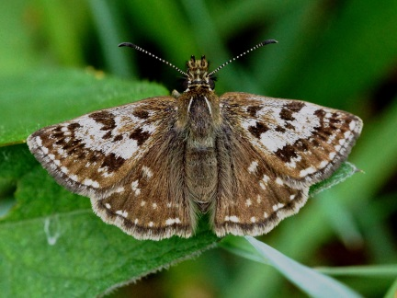  ©Brian Nelson | 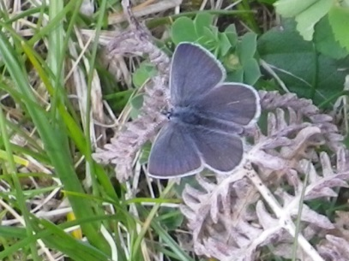 | 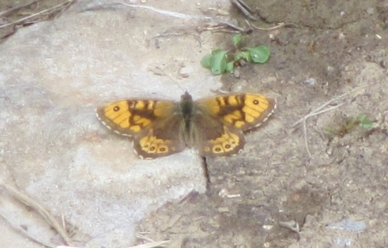
Fig. 9. The fantastic array of plants on the islands produces a corresponding selection of butterflies which depend on the plants: Dingy skipper, small blue and wall brown.

Avian fauna dependent on the farmed habitats
The bird life of the farmed habitats is also vibrant. Lapwing nesting on machair grassland is a common occurrence on the islands that is becoming increasingly rare elsewhere; this species is listed as a red list bird species indicating that it is of high conservation concern. Important numbers of terns (Arctic tern, Sandwich tern and Little tern) have been recorded breeding on the islands, these species over winter on Antarctic pack ice (arctic tern) and west coast of Africa (Sandwich tern and Little tern) and return to the Aran Islands to breed in Summer. Wheatear and Ringed plover also feed and nest on Machair (Fig. 10). All these species nest on the ground and so are prone to predation and disturbance (Fig 11).
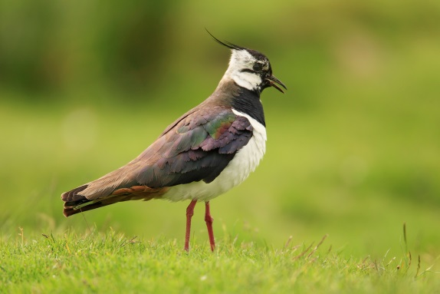 | 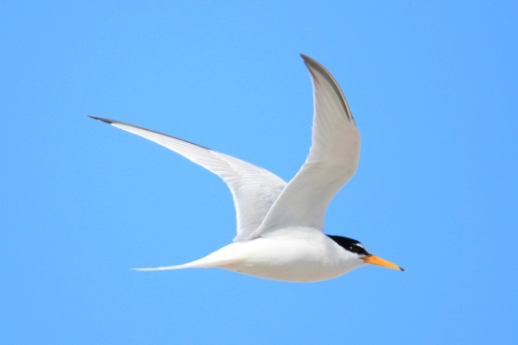
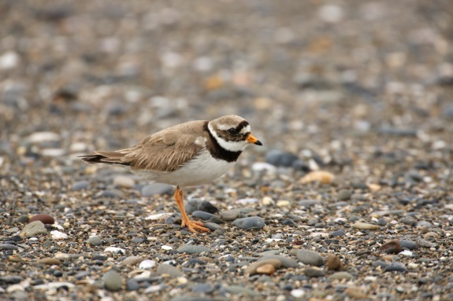 | 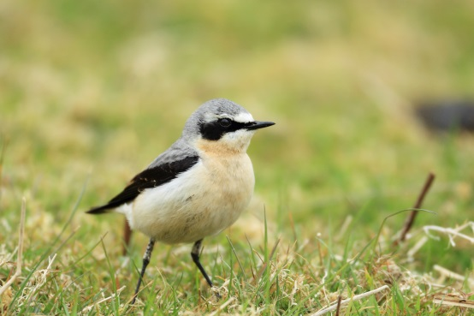
Fig. 10. Birds that nest and feed on the grazed machair habitat: Lapwing, Little tern, Ringed plover and Wheatear (Photos ©A.Walsh)

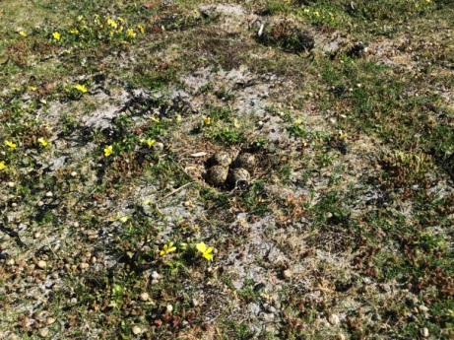
Fig 11. Effective camouflage of a Lapwings nest within a AranLIFE seaweed plot on machair grassland. Nest disturbance is a major factor in the decline of this species nationally.
Chough, a member of the crow family with distinctive red beak, requires short turf grazed grasslands to forage for insects and grubs (Fig. 12). This ideal habitat is created on the islands within the winter grazed lands that are then left ungrazed during the summer.
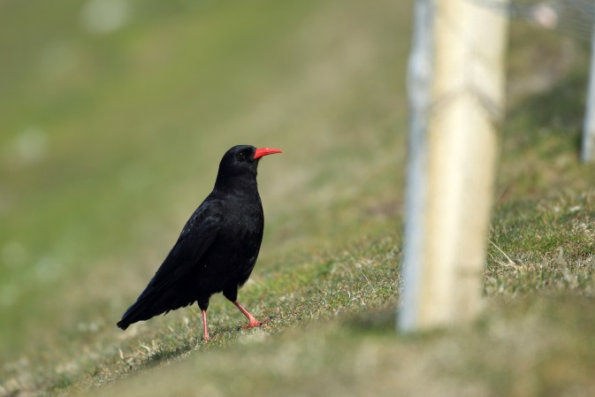
Fig. 12. Chough, feeds on insects and their larvae, worms and other underground invertebrates and needs short grazed grassland to forage.

Other important species dependent on the biodiversity
The invertebrate diversity of the islands is also extraordinary. The Aran Islands has its own variety of bumble bee, Bombus allenalus, var allenellus, that has only been recorded on these islands (Fig. 13).
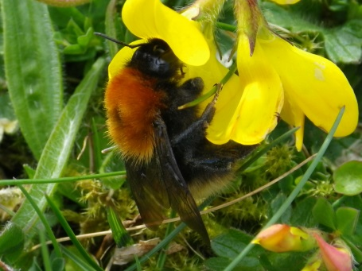
Fig. 13. The Aran Bumble bee
The narrow-mouthed whorled snail, Vertigo angustior, is a small, rare snail that occurs on machair habitat on Inis Mór (Fig. 14). This species can occur on a wide variety of sites however the exact micro-climate that it requires is very strict and it is sensitive to drainage, changes in grazing and management. This species is on Annex II of the EU habitats Directive and is considered threatened within Europe.
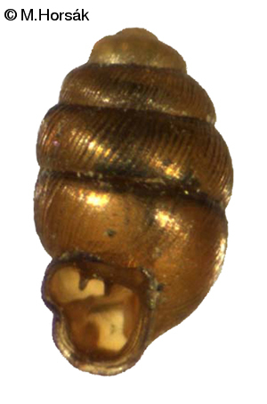
Fig. 14. The small snail Vertigo angustior which occurs on Inis Mór. The presence of this species indicates habitats the have not been disturbed as the hydrogeological requirements of this species are very precise and prone to disturbance through changes in management.

Optimal grazing score system
The Aran Islands is an incredible reserve of wildlife of high nature conservation value that is managed and conserved by the low-intensity farming practises that have been ongoing on the islands for generations. For the conservation of this resource, the continued farming and management of the habitats is vital and the conservation of these habitats benefits all, farmers, visitors and the entire Island community. Issues such as land abandonment, scrub encroachment and reduction in accessibility to disparate parts of the farm, threaten this biodiversity resource. To monitor the impacts of the actions of the project on the island’s grassland biodiversity, the project devised a scoring system which is dependent on the diversity of the farmed habitat and appropriate management of the habitat.
AranLIFEs scoring system is a simplified 5-point scale that is based on the presence of positive indicator species (Indicator species are listed in the report ’Ecosystem functions restoration resulting from the project actions II: Appendix1’)
Score 5
Score 5 represents good quality priority habitat. It is well managed with an appropriate grazing regime which usually involves grazing to a short turf in winter but may also involve a flash grazing during the summer if grass growth is good.
A score 5 has a high-species diversity with frequent positive indicator species, producing a colourful array of flowers during the summer months including an abundance of orchid species. Fertiliser is unlikely to have been applied to this grassland as doing so would reduce the species diversity significantly. Since the grazing intensity is at an optimum level, scrub and bracken encroachment is not an issue or has been rectified by cutting.

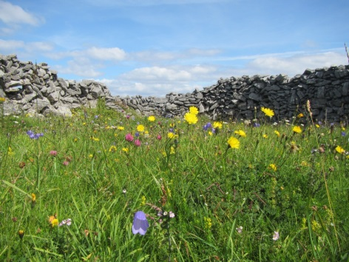 | 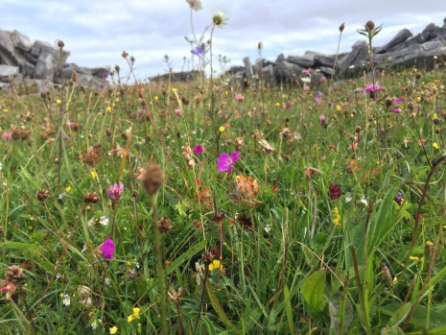
Fig. 14. Examples of Score 5 vegetation.
Score 4
Score 4 represents priority habitat with a high-species diversity with frequently occurring positive indicator species. The grazing level is appropriate for the most part, however, scrub or bracken encroachment an issue.
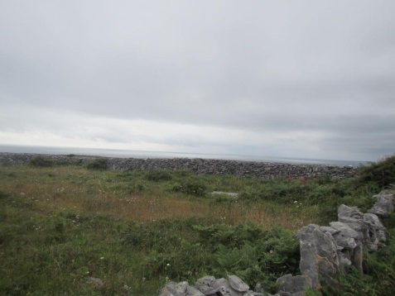 | 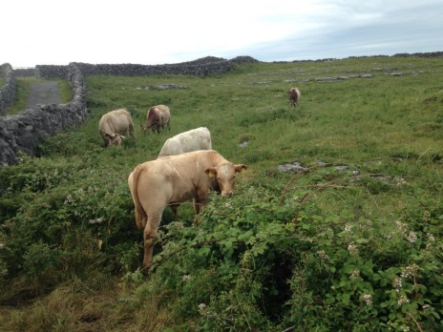
Fig. 15. Examples of Score 4 vegetation

Score 3b
Score 3b is priority habitat with a reduced number of positive indicator species. It has a low species diversity because of the inadequate grazing levels which favours a dominance of rank tall grasses and a higher sward height in summer, which shades out the herbaceous species typical of calcareous grassland. Scrub or bracken is usually an issue in these fields which is also a consequence of the sub-optimal grazing regime.

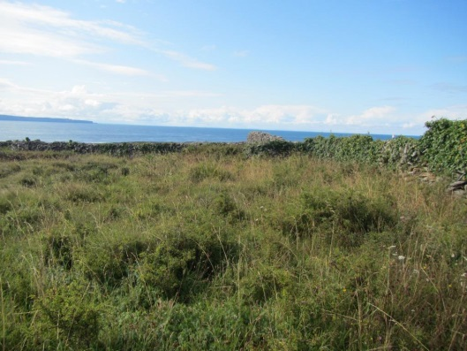 | 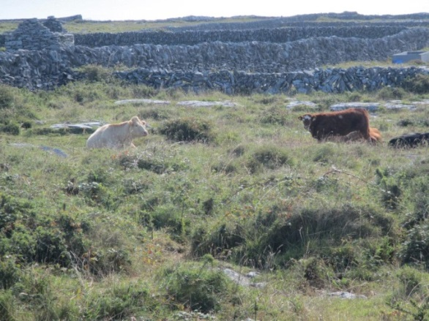
Fig. 16. Examples of score 3b fields.
Score 3a
Score 3a covers areas of priority habitat either where grazing is not occurring or where the grazing rate is so low it there is a substantial build-up of grass.
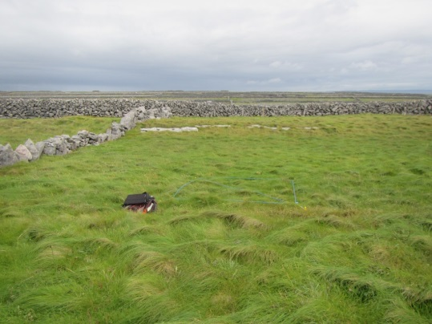 | 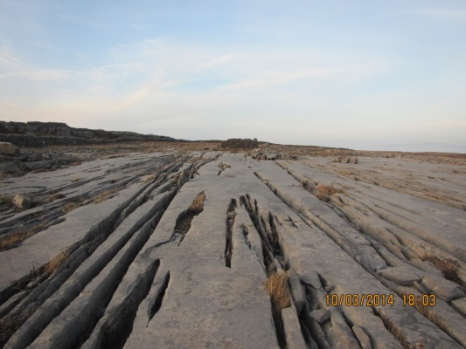
Fig. 17. Examples of unfarmed habitats that receive a score 3a.
Score 2
Score 2 represents Semi-improved grassland with limited indicators of priority habitat. The vegetation is grass dominated, with higher levels of fertility or typically occurs in more recently made grasslands.
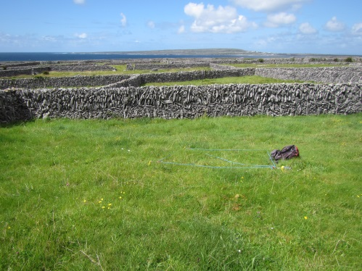
Fig. 17. Examples of Score 2 vegetation.

Score 1
Score 1 represents non-priority habitat or not one of the three habitats Orchid-rich grassland, limestone pavement or machair and therefore not covered by the LIFE project.

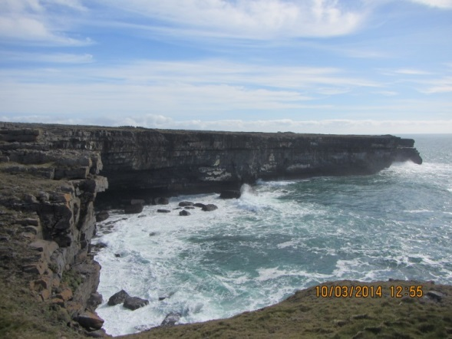
Fig. 18. Example of non-AranLIFE habitat.

Methodology

Grazing score analysis
Initial grazing scores (5 to 1) were given to land within the project in 2014 during the production of the farm plan.
During 2016 and 2017 all participants land within the project was resurveyed and given a score either 1, 2, 3a, 3b, 4 and 5 according to its conservation status, with 5 being the highest score (Table 1). The score of 3a was added in this survey period to account for areas of priority habitat that was not being grazed. Farmers received a payment in the last 2 years of the project based on these scores, (Score 5: €150/ha; Score 4: €125/ha; Score 3b: €100/ha; Scores 3a to Score 1: €0)
Table 1. Rationale for assigning field scores.
Farm Plot scores for grazing action
Score | Rationale
5 | Priority habitat perceived to be very well managed, indicated by a high number of positive indicator species and an appropriate grazing regime (lacking indicators of undergrazing and overgrazing)
4 | Priority habitat with a high number of positive indicator species and an appropriate grazing regime (lacking indicators of undergrazing and overgrazing) but with scrub or bracken encroachment an issue
3b | Priority habitat with reduced numbers of positive species indicators. Habitat is not optimally grazed and scrub encroachment may be an issue. Habitat may also support negative indicator species.
3a | Areas of priority habitat where grazing is not occurring or where the grazing rate is so low there is a substantial build-up of grass
2 | Semi-improved habitat with limited indicators of priority habitat, grass dominated, usually with higher levels of fertility or more recently made grasslands in an island context
1 | Non-priority habitat and therefore not covered by the LIFE project

Grazing score verification
During the 2017 field season, transects containing ten 1m² plots were recorded within L.P.s and/or fields to verify the optimal grazing scores given to these areas. A total of 39 transects (each with 10 1m²) were recorded across the three islands (Table 2). Locations of 1m² plots were randomly selected in a diagonal across or in a ‘w’ if the diagonal of the field was less than 100m. Locations of transects were selected to cover a range of grazing scores as well as large LPs where multiple scores were awarded and small LPs which aligned to single scores.
At each of the 10 stops or plots within the transect the presence of higher plants and dominant bryophytes was noted.

Table 2. The numbers of transects recorded in each island.
Inis Oírr | Inis Meáin | Inis Mór
14 transects | 12 transects | 13 transects

A number of transects were chosen which were thought to best represent the top 3 scores for which payment is received
 | No. of transects selected
Score 5 | 10
Score 4 | 8
Score 3b | 4
Score 3a | -
Score 2 | 4

The selection and analysis of these transects helps to achieve the following:
- Ascertain the indicators which distinguish the scores
- Refine the national species indicators to suit the Aran Island context

Results and Discussion

Comparison of field scores from 2014 and 2016

Year 1 vs year 3 scores
Comparison of grazing scores from 2014 and 2016 on Inis Oírr, Inis Meáin and Inis Mór shows a significant increase in areas scoring 5 (Fig. 19).

Fig. 19. Total Area = 1016ha. The change in grazing scores between year 1 of the project in 2014 and year 3 in 2016. Grazing scores 3a was introduced in 2016 to take account of priority habitat that was not being grazed.
In 2016, there was 511ha of score 5 fields in total (Table 3).
Table 3. The area of Score 5 in 2016 is made up of predominantly Score 4 fields that have had scrub removed. Score 0 are fields that were unscored in 2014.
2014 | 2016 | Area (ha)
Score 5 | Score 5 | 74ha
Score 4 | Score 5 | 267ha
Score 3 | Score 5 | 48ha
Score 0 | Score 5 | 122ha
 | Total | 511ha

Score 5 area increased by 315ha from 2014 to 2016, and most of this improvement is from score 4 fields that had scrub removed and implemented optimal grazing, since a total of 267ha went from a score 4 in 2014 to a score 5 in 2016 (Table 3).
In 2016, the area under Score 4 decreased by 207ha from 436ha to 228ha (Table 4).
Table 4. The breakdown of scores that went to a score 4 in 2016.
2014 | 2016 | Area (ha)
Score 5 | Score 4 | 4ha
Score 4 | Score 4 | 133ha
Score 3 | Score 4 | 36ha
Score 0 | Score 4 | 55ha
 | Total | 228ha

There was133ha of Score 4 in 2016 which was score 4 in 2014 that still has to have scrub removed in order to raise the score to 5 (Tabe 3).
Score 3a was introduced in 2016 to account for areas of priority habitat that had not been grazed. Score 3b covers land that supports priority habitat but is undergrazed and has a scrub encroachment issue.
Table 3. The breakdown of scores that went to Score 3a and 3b in 2016.
2014 | 2016 | Area | 2014 | 2016 | Area
Score 5 | Score 3b | 0ha | Score 5 | Score 3a | 4ha
Score 4 | Score 3b | 15ha | Score 4 | Score 3a | 17ha
Score 3 | Score 3b | 24ha | Score 3 | Score 3a | 4ha
Score 2 | Score 3b | 6ha | Score 2 | Score 3a | 3ha
Score 0 | Score 3b | 71ha | Score 0 | Score 3a | 55ha
Totals |  | 116ha |  |  | 199ha

Score 0 represents land which had not been given a score in 2014. In 2016 following resurvey most of the score 0 land was deemed to be either 3a (55ha) or 3b (71ha) (Table 3).
Unfarmed land is classed as Score 3a and this amounted to 199ha.

Table 4. Total area of land that had improved scores from 2014 to 2016
2014 | 2016
Score 4 | Score 5 | 267ha
Score 3 | Score 5 | 48ha
Score 3 | Score 4 | 36ha
Total |  | 351ha

A total of 351ha improved in score from 2014 to 2016 (Table 4).

Grazing score change on Islands
The area of habitat with improved score between 2014 and 2016 is most evident when seen in the island context in maps (Figs 20 to 22).
The most notable feature of the Inis Oírr grazing scores 2014 map (Fig. 20) is the lack of score 5 fields with Score 4 the most common grazing score throughout the island. These fields support priority habitat but their conservation value is reduced because of scrub encroachment or inappropriate grazing. Following 2 years of concrete actions of scrub cutting, improving access and provision of water infrastructure many of these score 4 fields have become score 5 fields in 2015. A similar scenario occurs on Inis Meáin (Fig. 21).
The orange colour in the 2016 map represents Score 3a which was introduced to cover areas that are priority habitat but is not grazed. Limestone pavement with deep grykes that is unsuitable for grazing would come under this grazing score.
The colour code for the grazing score maps is as follows:
Score 5
Score 4
Score 3b
Score 3a
Score 2

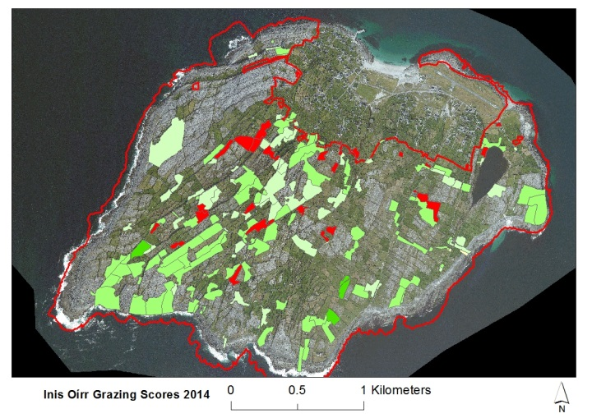 | 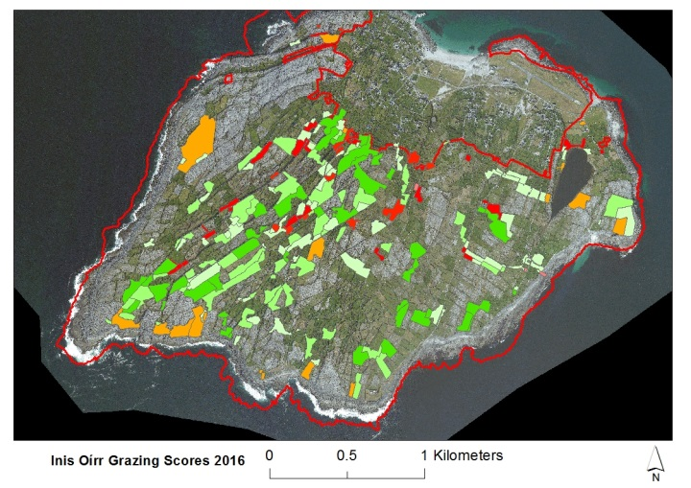
Fig.20. Change in grazing scores on Inis Oírr from 2014 to 2016. Darker green colour represents Score 5.
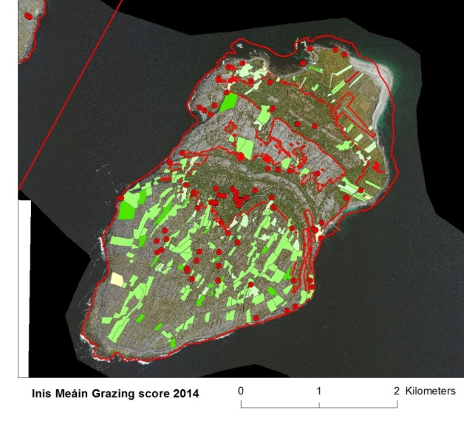 | 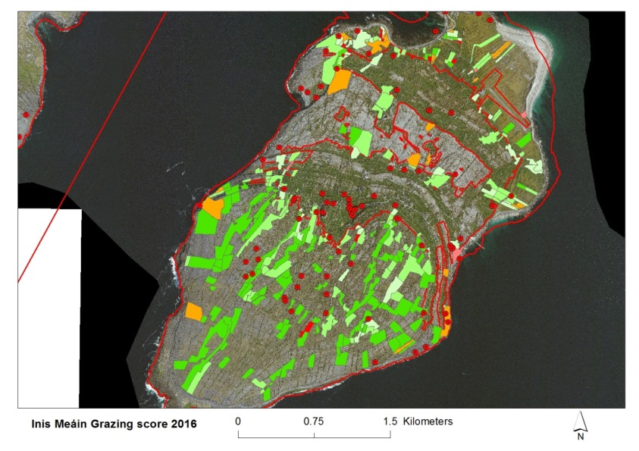
Fig. 21. Change in grazing score on Inis Meáin from 2014 to 2016

2014
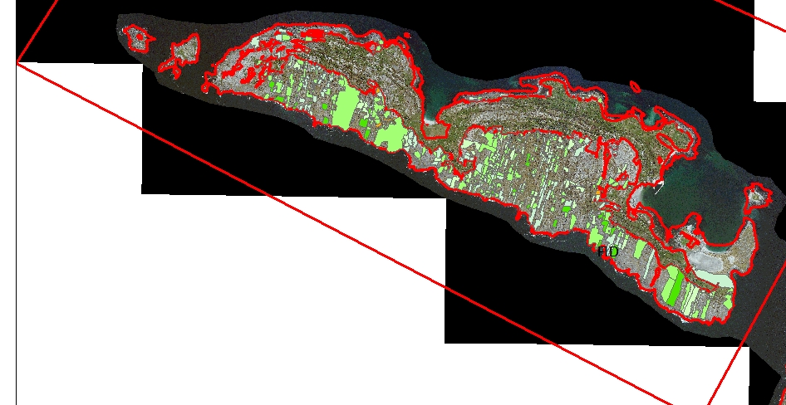

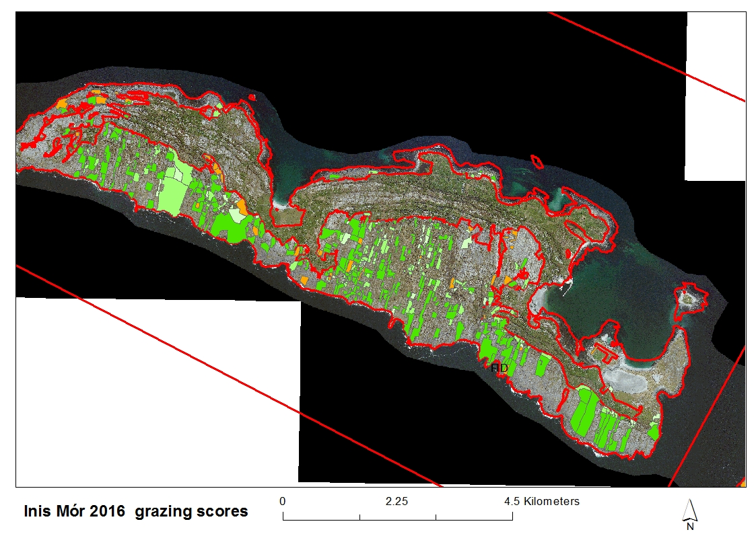
Fig.22. Change in grazing score on Inis Mór from 2014 to 2016

Total species diversity
From the analysis of the transects that are representative of particular grazing scores, the average number of species in each plot decreases with decreasing score, even though there is the range of total species recorded in each plot is similar for the first three grazing scores (Table 6). This overlap is to be expected however because fields or LPs representative of the top three grazing scores would be expected to have areas supporting species-rich grassland as well as pockets of less species-rich vegetation, with these less-species rich pockets more prevalent in the lower grazing scores.

Table 6. The average no. of species per plot in transects representative of each grazing score

Grazing score | Average no. of species per 1m² plot | Range of species in 1m² plot
Score 5 | 19.25 | 9 to 28
Score 4 | 15.8 | 4 to 28
Score 3b | 11.8 | 6 to 28
Score 3a | - | -
Score 2 | 9.8 | 4 to 19

Within the representative transect plots for scores 5 to 2 recorded within the grazing score analysis transects, the number of 1m² plots within each transect with 15 or more species decreases with decreasing score (Table 7 to 10).
Within these ten Score 5 representative transects, at least 7 out of 10 plots in each transect support 15 or more species (Table 7).
Table 7. Score 5 transect plots: All transects have 7 or more plots with 15 or more species in total.
No. of plots with 15+ species | PLT3-IMN | PLT4-IMN | PLT 8-IMN | PLT 7-IMR | PLT 10-IMR | PLT11-IMR | PLT 12-IMR | PLT8-IO | PLT9-IO | PLT10-IO
Score 5 | 9 | 7 | 9 | 10 | 10 | 10 | 10 | 10 | 10 | 10

Within the 8 transects representative of Score 4, six of the transects have 6 out of the 10 plots supporting 15 or more species. In transects PLT5IMR and PLT2IO, 4 and 3 of the plots respectively support 15 or more species (Table 8).
Table 8. Score 4: Total no. of plots in each transect representative of Score 4, with more than 15 species. Transects in bold have 6 out of 10 plots with 15 or more species.
No. of plots with 15+ species | PLT1-IMN | PLT 8 IMR | PLT 5 IMR | PLT 9-IMR | PLT2-IO | PLT4-IO | PLT11-IO | PLT12-IO
Score 4 | 6 | 9 | 4 | 7 | 3 | 6 | 6 | 8

Table 9. Number of plots in each Score 3b transect with 15 or more species
No. of plots with 15+ species | PLT1-IMR | PLT5-IO | PLT6-IO | PLT7-IO
Score 3 b | 1 | 5 | 2 | 0

Table 10. Number of score 2 plots with 15 or more species
No. of score 2 plots with 15+ species | PLT3-IMR | PLT4-IMR | PLT13-IMR | PLT3-IO
Score 2 | 2 | 2 | 1 | 0

The number of plots with high species diversity gives an indication of whether or not the transect area is Score 5. If most of the plots within the transect have more than 15 species in the 1m² plot that it is likely that the area of the transect is Score 5.

High quality, positive and negative Indicator species
High quality indicator species for orchid-rich calcareous grassland are particular species that are either associated with that plant community or are indicative of high quality habitat that were less agriculturally improved. The introduction of HQ indicator species was introduced by the ISGS to help clarify the distinction between Annex I grassland and non-Annex I grassland.
There are species In the ISGS list of there are 17 high quality positive species, and 14 positive species.

High quality positive species | Positive species
Antennaria dioica (Catspaw, Mountain Everlasting) | Arabis hirsuta (Hairy rock-cress)
Anthyllis vulneraria (Kidney Vetch) | Carex flacca (Glaucous sedge)
Asperula cynanchica (Squinancywort) | Ctenidium molluscum (Comb moss)
Blackstonia perfoliata (Yellow-wort) | Daucus carota (Wild carrot)
Briza media (Quaking grass) | Galium verum (Ladies Bedstraw)
Campanula rotundifolia (Harebell) | Helicototrichon pubescens(Downy oat-grass)
Carex caryophyllea (Spring sedge) | Homalothecium lutescens (Yellow feather-moss)
Carlina vulgaris (Carline Thistle) | Leontodon hispidus/L.saxatilis (Hawkbits)
Centaurea scabiosa (Greater knapweed) | Lotus corniculatus (Birdsfoot trefoil)
Gentiana verna (Spring gentian) | Pilosella officinarum (Mouse-ear-hawkweed)
Gentianella campestris (Field gentian) | Ranunculs bulbosus(Bulbous buttercup)
Geranium sanguineum (Bloody Cranesbill) | Sesleria caerulea (Blue Moor grass)
Knautia arvensis (Field scabious) | Thymus polytrichus(Wild Thyme)
Koeleria macrantha (Crested hair-grass) | Trisetum flavescens (Yellow oat grass)
Linum catharticum (Fairy flax)
Primula veris (Cowslip)
Sanguisorba minor (Salad Burnet)

A comparison was made between the frequency of occurrence of high quality indicator species and positive indicator species and the scores to see if the frequency of these indicator species diminished relative to decreasing score (Tables 11 and 12)

Table 11. Comparison of high quality positive species indicators with those that are also good indicators of score, with higher frequency occurring in higher scores.
High Quality Positive species | Score 5 %frequency  (n=100) | Score 4 %frequency (n=80 | Score 3b % frequency (n=40) | Score 2 %frequency (n=40) | good indicator species for Aran
Antennaria dioica (Mountain Everlasting) | 10.0 | 1.2 | 2.5 | 0
Anthyllis vulneraria (Kidney Vetch) | 16.0 | 8.2 | 0 | 0 | √
Asperula cynanchica (Squinancywort) | 12.0 | 2.4 | 0 | 0
Blackstonia perfoliata (Yellow-wort) | 2.0 | 1.2 | 0 | 0
Briza media (Quaking grass) | 22.0 | 17.6 | 10 | 0 | √
Campanula rotundifolia (Harebell) | 45.0 | 20.0 | 0 | 0 | √
Carex caryophyllea (Spring sedge) | 11.0 | 4.7 | 7.5 | 5
Carlina vulgaris (Carline Thistle) | 7.0 | 3.5 | 0 | 0 | √
Centaurea scabiosa (Greater knapweed) | 3.0 | 3.5 | 0 | 0
Gentiana verna (Spring gentian) | 0.0 | 0.0 | 0 | 0
Gentianella campestris (Field gentian) | 7.0 | 0.0 | 0 | 0
Geranium sanguineum (Bloody Cranesbill) | 74.0 | 61.2 | 47.5 | 5 | √
Knautia arvensis(Field scabious) | 0.0 | 0.0 | 0 | 0
Koeleria macrantha (Crested hair-grass) | 0.0 | 1.2 | 0 | 0
Linum catharticum (Fairy flax) | 50.0 | 24.7 | 0 | 0 | √
Primula veris (Cowslip) | 19.0 | 5.9 | 0 | 0 | √
Sanguisorba minor (Salad Burnet) | 66.0 | 44.7 | 15 | 7.5 | √

The high quality indicator species which occurred with high frequency in Score 5 plots and with low frequency in score 2 plots were: Anthyllis vulneraria, Briza media, Campanula rotundifolia, Carlina vulgaris, Geranium sanguineum, Linum catharticum, Primula veris and Sanguisorba minor (Table 11).
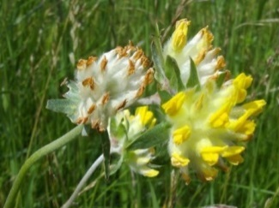 |  | 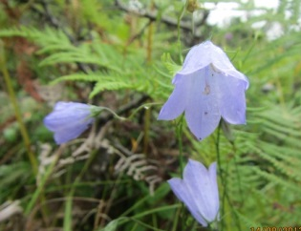
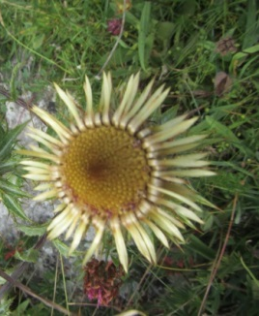 | 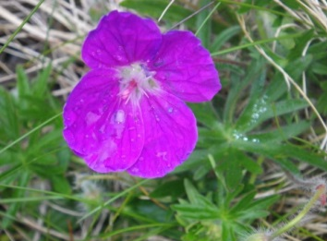 | 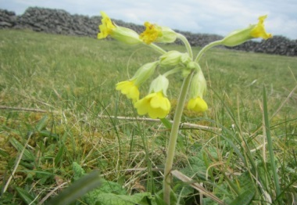
Fig. 23. Some high quality indicator species that decrease in frequency with decreasing score.

Table 12. Positive indicator species that have affinities with higher scores
Positive Species | Score 5 %frequency  (n=100) | Score 4 %frequency (n=80 | Score 3b % frequency (n=40) | Score 2 %frequency (n=40) | good indicator species for Aran
Arabis hirsuta (Hairy rock-cress) | 0.0 | 0.0 | 0 | 0
Carex flacca (Glaucous sedge) | 83.0 | 38.8 | 27.5 | 7.5 | √
Ctenidium molluscum(Comb moss) | 0.0 | 0.0 | 0 | 0
Daucus carota (Wild carrot) | 29.0 | 30.6 | 5 | 20
Galium verum (Ladies Bedstraw) | 52.0 | 45.9 | 27.5 | 10 | √
Helicototrichon pubescens(Downy oat-grass) | 0.0 | 0.0 | 0 | 0
Homalothecium lutescens (Yellow feather-moss) | 0.0 | 0.0 | 0 | 0
Leontodon hispidus/L.saxatilis (Hawkbits) | 22.0 | 3.5 | 2.5 | 0
Lotus corniculatus (Birdsfoot trefoil) | 79.0 | 61.2 | 72.5 | 12.5
Pilosella officinarum (Mouse-ear-hawkweed) | 22.0 | 4.7 | 0 | 0 | √
Ranunculs bulbosus(Bulbous buttercup) | 2.0 | 2.4 | 10 | 5
Sesleria caerulea (Blue Moor grass) | 46.0 | 21.2 | 12.5 | 0 | √
Thymus polytrichus(Wild Thyme) | 31.0 | 16.5 | 0 | 0 | √
Trisetum flavescens (Yellow oat grass) | 0.0 | 0.0 | 0 | 2.5

Positive indicator species which decreased in frequency with decreasing score were Carex flacca, Galium verum, Pilosella officinarum, Sesleria caerulea and Thymus polytrichus.
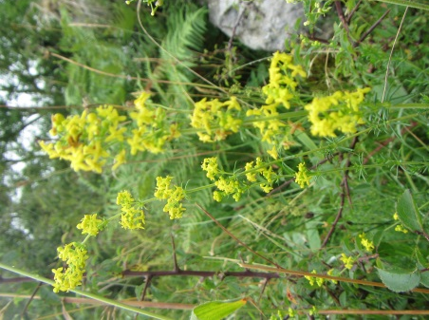 | 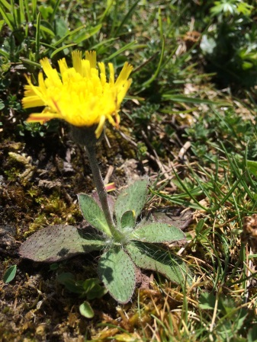
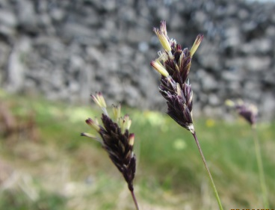 | 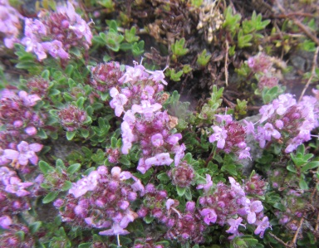
Fig 24. Photos of positive indicator species which decrease with decreasing score
An additional set of species, which were not on existing indicator species list, show a decrease in frequency with decreasing score (Table 13) and these species are also appropriate species for indicating calcareous grasslands of high conservation value in the context of the Aran Islands.
Table 13. Additional species which decline in frequency with decreasing scores
Additional positive species | Score 5 %frequency  (n=100 | Score 4 %frequency (n=80 | Score 3b % frequency (n=40) | Score 2 %frequency (n=40) | good indicator species for Aran
Agrimonia eupatoria (Hemp agrimony) | 4.0 | 1.2 | 0 | 0 | √
Calluna vulgaris (Ling heather) | 32.0 | 12.9 | 5 | 0 | √
Carex species (Sedges) | 6.0 | 4.7 | 2.5 | 0 | √
Euphrasia officinalis (Eye bright) | 76.0 | 36.5 | 0 | 0 | √
Plantago maritima (Sea plantain) | 29.0 | 8.2 | 0 | 0 | √
Polygala vulgaris (Common milkwort) | 27.0 | 7.1 | 2.5 | 0 | √
Rhinanthus minor (Yellow rattle) | 36.0 | 10.6 | 2.5 | 2.5 | √
Succisa pratensis (Devil’s bit Scabious) | 77.0 | 36.5 | 12.5 | 2.5 | √

Fig. 24. Some additional species which are appropriate indicator species in the context of the Aran Island.
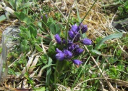

Cock’s foot Dactylis glomerata appears to increase in frequency with decreasing score, however, it is quite abundant even in high scores (Table 14). This grass species continues growing during the autumn unlike most grasses and therefore is an important grass species in the winter grazed Winterages.

Table 14. Negative species in ISGS and their affinities with lower scores
Negative Indicator species | Score 5 %frequency  (n=100) | Score 4 %frequency (n=80 | Score 3b % frequency (n=40) | Score 2 %frequency (n=40) | good indicator species for Aran
Arrhenatherum elatius (False oat grass) | 16.0 | 40.0 | 27.5 | 10
Cirsium arvense (Creeping thistle) | 0.0 | 0.0 | 0 | 0
Cirsium vulgare (Spear thistle) | 0.0 | 1.2 | 0 | 0
Dactylis glomerata (Cock's foot grass) | 31.0 | 51.8 | 52.5 | 90 | √
Lolum perenne (Perennial rye grass) | 1.0 | 8.2 | 35 | 20 | √
Rumex crispus (Curled leaf dock) | 1.0 | 0.0 | 0 | 0
Rumex obtusifolius (Broad leaved dock) | 0.0 | 0.0 | 0 | 7.5 | √
Senecio jacobaea (ragwort) | 13.0 | 12.9 | 25 | 0
Trifolium repens (white clover) | 26.0 | 18.8 | 37.5 | 12.5 | X
Urtica dioica (Nettle) | 0.0 | 0.0 | 0 | 7.5 | √
Extra negative species
Pteridium aquilinum (Bracken) | 26.0 | 32.9 | 12.5 | 52.5 | √
Prunus spinosa (Blackthorn) | 18.0 | 23.5 | 12.5 | 12.5
Rubus fruticosus (Bramble) | 18.0 | 27.1 | 22.5 | 47.5 | √

Indicator species analysis
Indicator species analysis was conducted on the 4 groups and the resulting indicator species identified. The best indicators are the ones with significant p values and highest indicator value which is a product of their relative abundance and frequency with the max group. As already identified in %frequency analysis, there are a number of good indicators for Score 5 but also for Score 2 (Rubus fruticosus, Pteridium aquilinum). Species typical of semi-improved pasture align with Score 2 (Table 15 and 16).
Table 15. Indicator Analysis showing the species which correlated best with Score 5. Also shown are the species which are high quality, positive indicator species and which species were indicator species in Aran Island context as derived from %frequency in plot analysis.
 | Maxgrp | Indicator value | Mean | S.Dev | p | HQ | Positive | AL
Euphrasia officinalis | 5 | 51.4 | 13.9 | 2.18 | 0.0002 |  |  | √
Succisa pratensis | 5 | 46.2 | 14.5 | 2.08 | 0.0002 |  |  | √
Carex flacca | 5 | 43.9 | 16 | 2.08 | 0.0002 |  | √
Linum catharticum | 5 | 33.5 | 10.3 | 2.09 | 0.0002 | √
Sanguisorba minor | 5 | 32.7 | 14.5 | 2.15 | 0.0002 | √
Campanula rotundifolia | 5 | 31.2 | 9.3 | 2.06 | 0.0002 | √
Potentilla erecta | 5 | 30.7 | 12.7 | 2.15 | 0.0002
Sesleria caerulea | 5 | 26.6 | 10 | 2.08 | 0.0002 |  | √
Rhinanthus minor | 5 | 25.1 | 7.6 | 1.93 | 0.0002 |  |  | √
Viola species | 5 | 23.6 | 7.1 | 1.91 | 0.0002
Prunella vulgaris | 5 | 23.3 | 9.5 | 2.02 | 0.0002
Plalantago maritima | 5 | 22.6 | 6.4 | 1.86 | 0.0002 |  |  | √
Polygala vulgaris | 5 | 19.9 | 6.1 | 1.84 | 0.0002 |  |  | √
Geranium sanguineum | 5 | 29.2 | 17.6 | 2.07 | 0.0004 | √
Thymus polytrichus | 5 | 20.2 | 7.4 | 1.93 | 0.0004 |  | √
Pilosella officinarum | 5 | 18.1 | 5.1 | 1.72 | 0.0004 |  | √
Calluna vulgaris | 5 | 20.5 | 7.4 | 1.95 | 0.0006 |  |  | √
Leontodon hispidus | 5 | 17.3 | 5.2 | 1.79 | 0.0006 |  | √
Lotus corniculatus | 5 | 27.7 | 19.1 | 1.93 | 0.0012 |  | √
Achillea millefolium | 5 | 21.8 | 11.5 | 2.15 | 0.0018
Leucanthemum vulgare | 5 | 18.7 | 11.1 | 2.15 | 0.0076
Galium verum | 5 | 20 | 13.7 | 2.1 | 0.0138 |  | √
Centaurea nigra | 5 | 16.7 | 12.6 | 2.04 | 0.0466

Table 16. Indicator species analysis shows that certain species are consistently markers of Score 2 vegetation.
 | Maxgrp | Indicator value | Mean | S.Dev | p | Negative indicator species
Dactylis glomerata | 2 | 36 | 16.1 | 2.03 | 0.0002 | √
Ranunculus repens | 2 | 28.1 | 6.4 | 1.79 | 0.0002
Veronica chamaedrys | 2 | 27.5 | 7.6 | 1.9 | 0.0002
Smyrnium olusatrum | 2 | 20.2 | 2.9 | 1.39 | 0.0002
Primula vulgaris | 2 | 19.1 | 4.8 | 1.69 | 0.0002
Pteridium aquilinum | 2 | 22.2 | 11.1 | 2.05 | 0.0004 | √
Rumex acetosa | 2 | 21 | 9.9 | 2.04 | 0.0006
Agrostis stolonifera | 2 | 21.6 | 10.3 | 2.07 | 0.0008
Rubus fruticosus | 2 | 19.6 | 10 | 2.08 | 0.002 | √

Cocks foot grass Dactylis glomerata is present in both Score 5 plots and Score 2 plots with increasing frequency with decreasing score. This species is an important component of the Winterage fodder as it exhibits autumnal growth (Beddows 1959). By being listed as a negative indicator species in the national assessment criteria, it gives the impression that this is an unwanted species in calcareous grasslands, which is not the case where Winterage system is practised.

Classification of vegetation in each of the grazing scores – ERICA

The Vegetation Classification programme, ERICA, is able to classify vegetation according to presence or absence. The plot data form transects representative of Score 5, Score 4, 3b and 2 were input into ERICA to see which grassland vegetation communities they represent and to investigate if there a difference in grassland type according to score.

Hierarchy of Grassland Community Classification
Groups and grasslands that occur within the grazing score representative transects are highlighted as identified by ERICA

Table 17. Grassland groups and communities that occur within grazing score plots that were analysed by ERICA. Highlighted communities occur within the grazing score transects. This hierarchy of grassland vegetation classification was produced following the national survey of grasslands (O’Neill et al. 2013)
GL1 Juncus acutiflorus-Molina caerulea group
GL1A Juncus acutiflorus-Holcus lanatus grassland
GL1B Agrostis stolonifera-Filipendula umalria marsh grassland
GLBi Caltha palustris-Carex disticha sub-community
GLBii Leontodon autmunalis-Lotus corniculatus sub-community
GL1C Molinia caerulea-Succisa pratensis grassland
GL1D Molinia caerula-Agrostis stolonifera-Potentilla erecta grassland
GLDi Filipendula ulmaria-Hydrocotyle vulgaris sub-community
GLDii Holcus lanatus-Festuca rubra sub-community
GLDiii Calluna vulgais-Nardus sctricta sub-community
GLE Juncus acutiflurus-Rhytidiadelphus squarrosus grassland
GL2 Agrostis stolonifera-Ranunculus repens group
GL2A Agrostis stolonifera-Ranunculus repens marsh grassland
GL2B Juncus effuses-Holcus lanatus grassland
GL2C Holcus lanatus-Lolium perenne grassland
GLD Juncus effusus-Rumex acetosa grassland
GL3 Cynosurus cristatus-Plantago lanceolata group
GL3A Briza media-Thymus polytrichus grassland
GL3Ai Sesleria caerulea-Tortella tortuosa sub-community
GL3Aii Cynosurus cristatus-Centauerea nigra sub-community
GL3B Lolium perenne-Trifolium repens grassland
GL3Bi Cynosurus cristatus-Festuca rubra sub-community
GL3Bii Poa annua-Plantago major sub-community
GL3Biii Lolium perenne sub-community
GL3C Festuca rubra-Plantago lanceolata grassland
GL3D Cynosurus cristatus-Trifolium pratense grassland
GL3E Festuca rubra-Rhinanthus minor grassland
GL3F Festuca rubra-Lotus corniculatus grassland
GL3Fi Plantago maritima- Plantago coronopus sub-community
GL3FiiFestuca rubra-Poa pratensis agg. sub-community
GL4 Nardus stricta-Galium saxatile group

Grazing scores and Vegetation types.
Score 5 plots aligned with GL3C which is synonymous with Annex I priority habitat *6210 orchid-rich calcareous grassland vegetation (Fig.24). As the score decreases the contribution of GL3A to the vegetation also decreases (Figs 24 to 26).
Score 5
Most of the plots assigned to Score 5 can be classified as GL3A Briza media-Thymus polytrichus grassland which is the Vegetation type synonymous with EU Annex I habitat *6210 Festuc-Brometalia (orchid-rich calcareous grassland priority habitat) (Fig.24) .

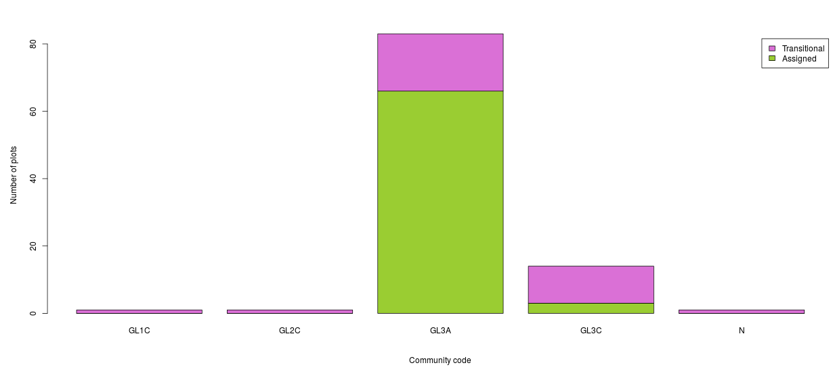 Fig. 24. Most of the plots assigned to Score 5 can be classified as GL3A Briza media-Thymus polytrichus grassland
Score 4
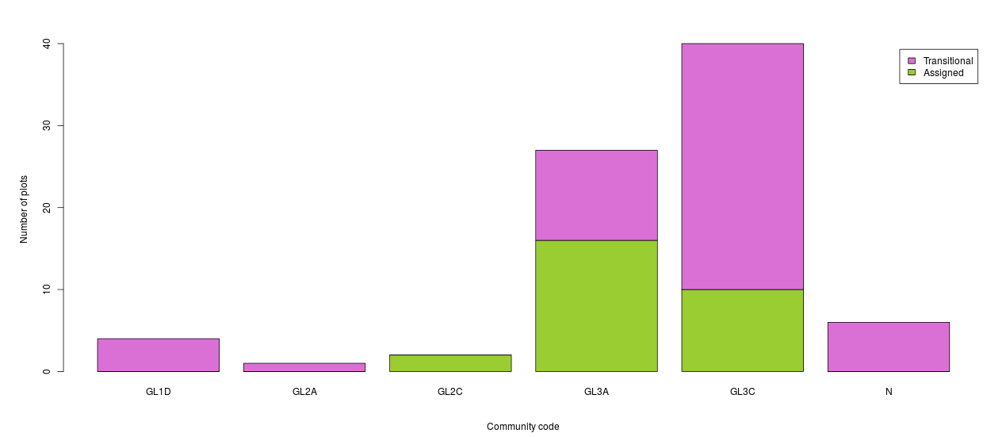
Fig. 25. Score 4 transect plots are predominantly aligned with GL3A Briza media-Thymus polytrichus grassland as well as GL3C grassland

Score 3b
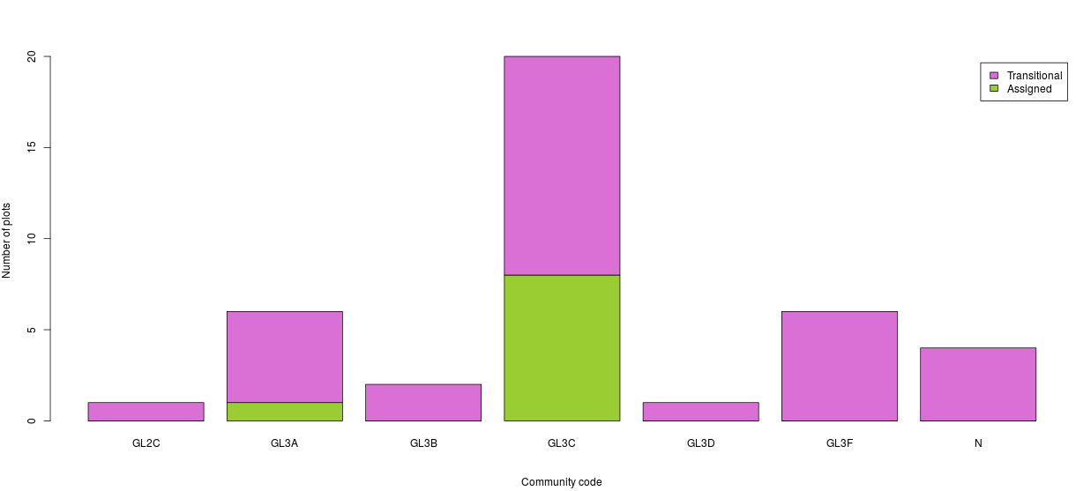
Fig. 26. Score 3b consists of elements of a range of grassland types with GL3C Festuca rubra-Plantago lanceolata grassland and GL3a occurring most frequently.
Score 2
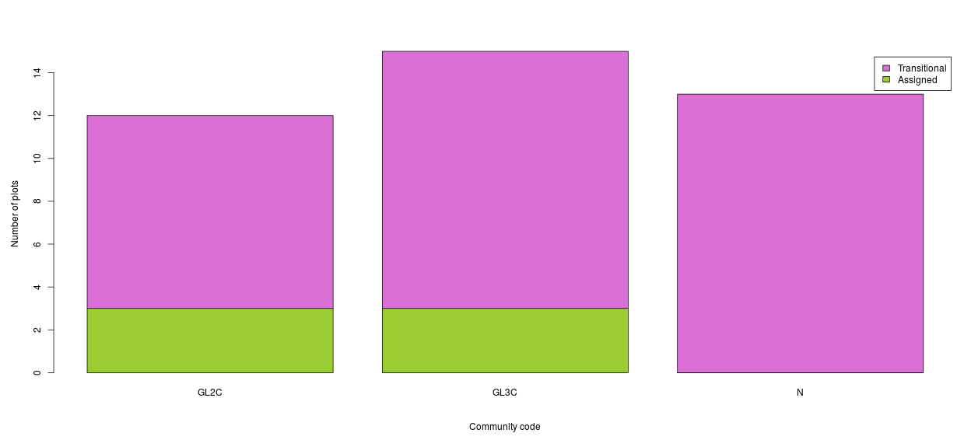
Fig. 27. In Score 2 transect plots, there are elements of GL2C Holcus lanatus-Lolium perenne grassland and GL3C Festuca rubra-Plantago lanceolata grassland

Conclusions
- The number of plots within a transect (maximum number of 10 plots) with high species diversity gives an indication of whether or not the transect area is Score 5. If seven or more plots within the transect have more than 15 species in the 1m² plot that it is likely that the area of the transect is Score 5.
- The high quality indicator species which occurred with high frequency in Score 5 plots and with low frequency in score 2 plots were: Anthyllis vulneraria, Briza media, Campanula rotundifolia, Carlina vulgaris, Geranium sanguineum, Linum catharticum, Primula veris and Sanguisorba minor.
- The Positive indicator species that decreased in frequency with decreasing score were Carex flacca, Galium verum, Pilosella officinarum, Sesleria caerulea and Thymus polytrichus.
- An additional set of species, which were not on existing indicator species list, show a decrease in frequency with decreasing score:
Agrimonia eupatoria (Hemp agrimony)
Calluna vulgaris (Ling heather)
Carex species (Sedges)
Euphrasia officinalis (Eye bright)
Plantago maritima (Sea plantain)
Polygala vulgaris (Common milkwort)

- These species are also appropriate species for indicating calcareous grasslands of high conservation value in the context of the Aran Islands.
- Cock’s foot Dactylis glomerata is an important component of the Winterage fodder as it exhibits autumnal growth. By being listed as a negative indicator species in the national assessment criteria, it gives the impression that this is an unwanted species in calcareous grasslands, which is not the case where Winterage system is practised.
- Most of the plots assigned to Score 5 can be classified as GL3A Briza media-Thymus polytrichus grassland which is the Vegetation type synonymous with EU Annex I habitat *6210 Festuc-Brometalia (orchid-rich calcareous grassland priority habitat).
- AranLIFE scoring system is an effective tool to investigate the impact of the project actions such as scrub cutting, provision of water infrastructure and improving access, on the biodiversity of the grassland habitats of the islands.
- By recording the vegetation in 10 x 1m² plots along transects over the field or land parcel, an overview of the vegetation can investigated. The mosaic of habitats that may occur (orchid-rich grassland, hay meadow vegetation, semi-improved swards) can then be analysed at field level, and the contribution of each can be assessed. This enables a practical conservation assessment and field score to be assigned to each field and/or land parcel.
- AranLIFE project scoring system is simple to implement and to understand which makes it possible for it to be part of a self-scoring system when used in assessing the conservation value of calcareous grassland in future schemes.

References
Beddows, A. R., (1959). Dactylis glomerata L. (Ed. 11) No. 2169. List Br. Vasc. Pl. No. 6781 [Biological Flora of the British Isles. Journal of Ecology 47(1), 223-39
Daily, G. (1997) Introduction: What Are Ecosystem Services? in Daily, G. (ed), Nature‘s Services. Societal Dependence on Natural Ecosystems, Island Press, Washington DC.
Costanza, R., d‘Arge, R., de Groot, R., Farber, S., Grasso, M., Hannon, B., Limburg, K., Naeem, S., O‘Neill, R. V., Paruelo, J., Raskin, R. G., Sutton, P., van den Belt, M. (1997) The value of the world‘s ecosystem services and natural capital, Nature, 387, 253-260.
Delaney, A., Devaney, F.M., Martin, J.M. and Barron, S.J. (2013). Monitoring survey of Annex I sand dune habitats in Ireland. Irish Wildlife Manuals, No. 75. National Parks and Wildlife Service, Department of Arts, Heritage and the Gaeltacht, Dublin, Ireland.
NPWS(2013). The Status of Protected EU Habitats and Species in Ireland. Overview Volume 1. Unpublished Report. National Parks & Wildlife Services. Department of Arts, Heritage and the Gaeltacht, Dublin , Ireland.
O’Neill, F.H., Martin, J.R., Devaney, F.M. & Perrin, P.M. (2013). The Irish semi-natural grasslands survey 2007-2012. Irish Wildlife Manuals, No.78. National Parks and Wildlife Service, Department of Arts, Heritage and the Gaeltacht, Ireland.
Sekercioglu, H.S. (2010). Ecosystem functions and services. In: Conservation Biology for all, N.S Sodhi & P.R. Ehrlich (Eds).
UK National Ecosystem Assessment. 2011. The UK National Ecosystem Assessment Technical Report. UNEP-WCMC, Cambridge.
Wilson, S. & Fernández, F. (2013). National survey of limestone pavement and associated habitats in Ireland. Irish Wildlife Manuals, No.73. National Parks and Wildlife Service, Department of Arts, Heritage and the Gaeltacht, Ireland.

