 | 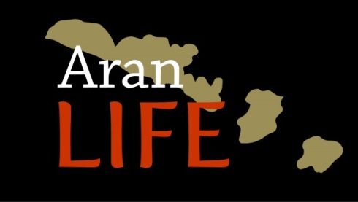 | 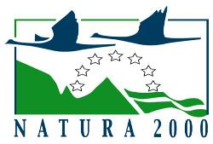

7.2.6 An assessment of scrub management practices on the Aran Islands
Louise Duignan, James Moran, John Finn & Daire Ó hUallacháin
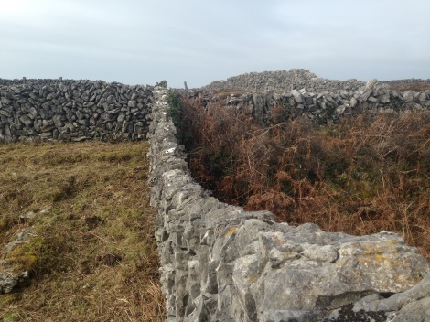

December 2018

Table of Contents

List of Figures ii
Introduction 1
Methods 3
Site overview 3
Scrub removal methodologies 4
Field survey methodology 6
Field relevé data 6
Transect data 6

Results and Discussion 8
Scrub cover and plant species richness 8
Scrub cover and positive indicator richness 9
Scrub treatment and scrub cover 10
Scrub treatment and scrub type 11
Scrub treatment and positive indicator cover 12
Scrub treatment and positive indicator count 13
Scrub treatment and negative indicator cover 14
Scrub treatment, scrub type and positive indicator cover 15
Scrub treatment, scrub type and positive indicator count 16
Scrub treatment, scrub type and negative indicator cover 17

Synopsis 18

Cover image courtesy of AranLIFE Best Practice Guide: Scrub management on the Aran Islands

List of Figures
Figure 1. Location of study plots on the Aran Islands. 3
Figure 2. Farmer removing scrub by hand on the Aran Islands 4
Figure 3. Goats grazing scrub on the Aran Islands 5
Figure 4. Scrub encroachment on the Aran Islands 7
Figure 5. Botanical sampling on the Aran Islands 7
Figure 6. Scrub cover on the dominant grassland types of the Aran Islands 8
Figure 7. Association between scrub cover and the cover of high quality
indicator species 9
Figure 8. Response of scrub cover to scrub control treatment 10
Figure 9. Impact of scrub treatment on scrub type. 11
Figure 10. Impact of scrub treatment on cover of high quality indicators 12
Figure 11. Impact of scrub treatment on count of high quality indicators 13
Figure 12. Impact of scrub control treatment on cover of negative indicators 14
Figure 13. Impact of scrub treatment on cover of positive indicators 15
Figure 14. Impact of scrub treatment on count of positive indicators 16
Figure 15. Impact of scrub treatment on cover of negative indicators 17

Introduction
The Aran Islands are an extremely important site for a number of priority terrestrial habitats under the Habitats Directive (Annex 1) resulting in over 75% of the total land area of the Aran Islands (4,500 ha) being designated as Natura 2000 sites. The agricultural landscape is largely a mosaic of rare Annex I European farmland habitat types of high conservation value – limestone pavement, machair and orchid-rich calcareous grassland.
The long history of farming on the Aran Islands has deeply influenced the nature of pastoral landscape as we know it today. Farm management activities, in particular grazing management with livestock, have created and maintained the calcareous grassland habitats that we value for their biodiversity.
However, scrub encroachment has been identified as a major threat to priority habitats on the Aran Islands. There are a variety of reasons that scrub persists on the Aran Islands. Typical farm holdings on the Aran Islands are highly fragmented and relatively small-scale with lower than average stocking rates (<0.5 LU/ha), with most herds numbering less than ten animals. Poor economic return from such small holdings is leading to a reduction of farming on the islands. The Department of Agriculture Food and the Marine estimates that the number of farms on the islands has decreased by more than 30% in the last 15 years.
Informal interviews with landowners on the Aran Islands identified the following factors that may influence scrub occurrence:
- Decline in sheep, especially for grazing creigs
- Decline in grazing by donkeys, particularly along roads and boreens.
- Current cattle breeds on the islands are less hardy than those used in the past, current breeds struggle to access certain areas of the farm with difficult terrain.
- In the past cattle were typically kept by the farmer until two-years of age. These older cattle were considered more light-footed and better able to browse scrub on more difficult terrain compared to the mature cow.
- Changes to grazing practices and associated supplementary feeding practices
- A decline in scrub control management. Historically farmers dedicated more time to scrub management, preventing scrub from proliferating. Also, scrub was once a valuable resource used for burning and thatching.
- Lack of manpower available compared to what was available in the past
The primary aim of this research was to assess trends on the effectiveness of various methods of scrub management employed by farmers on scrub control and also the impact of scrub management practices on botanical composition across a range of sites on the Aran Islands. Knowledge on the impact of scrub control methods can ensure that appropriate scrub management plans can be developed to protect the natural and cultural heritage associated with calcareous grasslands of high conservation value on the Aran Islands.

This study is part of the larger EU LIFE-funded AranLIFE project (2014-2018). AranLIFE is working with farmers to demonstrate best management practices for the conservation of priority EU-protected habitats that are dependent on a continued farming system.

Further detailed information on scrub management is included in the AranLIFE Best Practice Guide: Scrub management on the Aran Islands

Methods
Site overview
The study was carried out on the three Aran Islands in the west of Ireland (Fig. 1). The Aran Islands are situated approximately 10 km off the west coast of Co. Clare (Latitude 53° 05'N, Longitude 09° 35'W, 0-90m above sea level). The islands are a geological extension of the karstic Carboniferous region of the Burren (Co. Clare). Upper Carboniferous limestone strata, interleaved with layers of shale and clay, form these exposed islands. The soil cover is thin, with pockets of rendzina between the bare limestone. The three main islands extend to approximately 46km².
The islands have a temperate, mild climate. Average air temperatures range from 7 °C (44.6 °F) in January to 16°C (60.8 °F) in July. Rainfall is high, the yearly average (1995-2017) being 1208 mm (www.met.ie). The wettest months are between October and January with approximately 134 mm of rainfall per month during these months. The driest months are April and May with mean rainfall levels of approximately 70 mm per month (1995-2017).

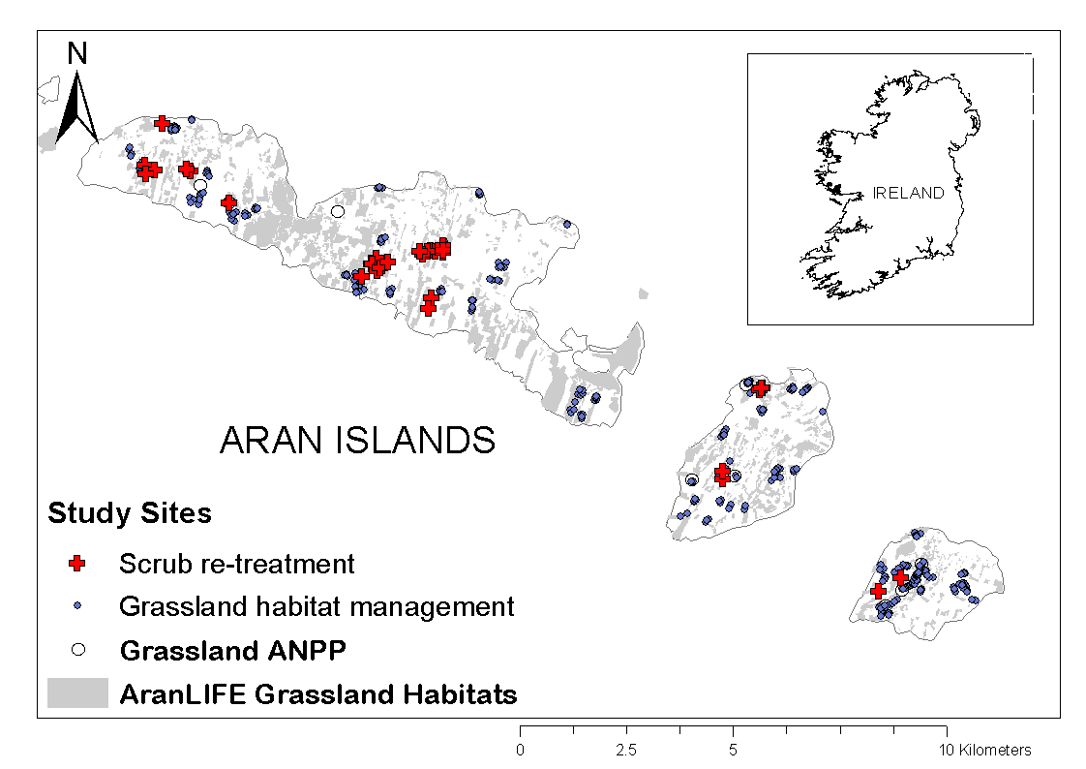
Figure 1: Location of study plots on the Aran Islands.

Scrub removal methodologies
This study assessed the impact of the three primary scrub control methods employed by landowners as part of the AranLIFE project on 25-27 scrub removal sites. Collection of scrub cover and botanical composition details were beyond the scope of this study.
Scrub was removed by hand in 2015. The three primary scrub treatments were:
- Cut once between 31/08 to 01/03 and no follow-up retreatment (1xCut)
- Cut between 31/08 to 01/03 and regrowth retreated with additional cut during the plant growing season (>1xCut)
- First cut between 31/08 to 01/03 and regrowth retreated with targeted herbicide application during the plant growing season (1xCut+herbicide)

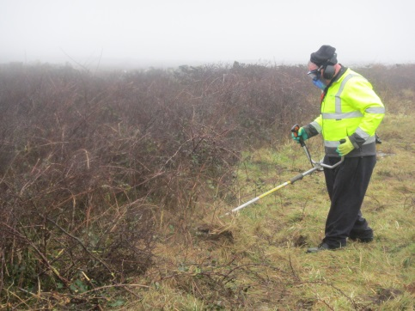
Figure 2: Farmer removing scrub by hand on the Aran Islands. (Image courtesy of AranLIFE Best Practice Guide: Scrub management on the Aran Islands)

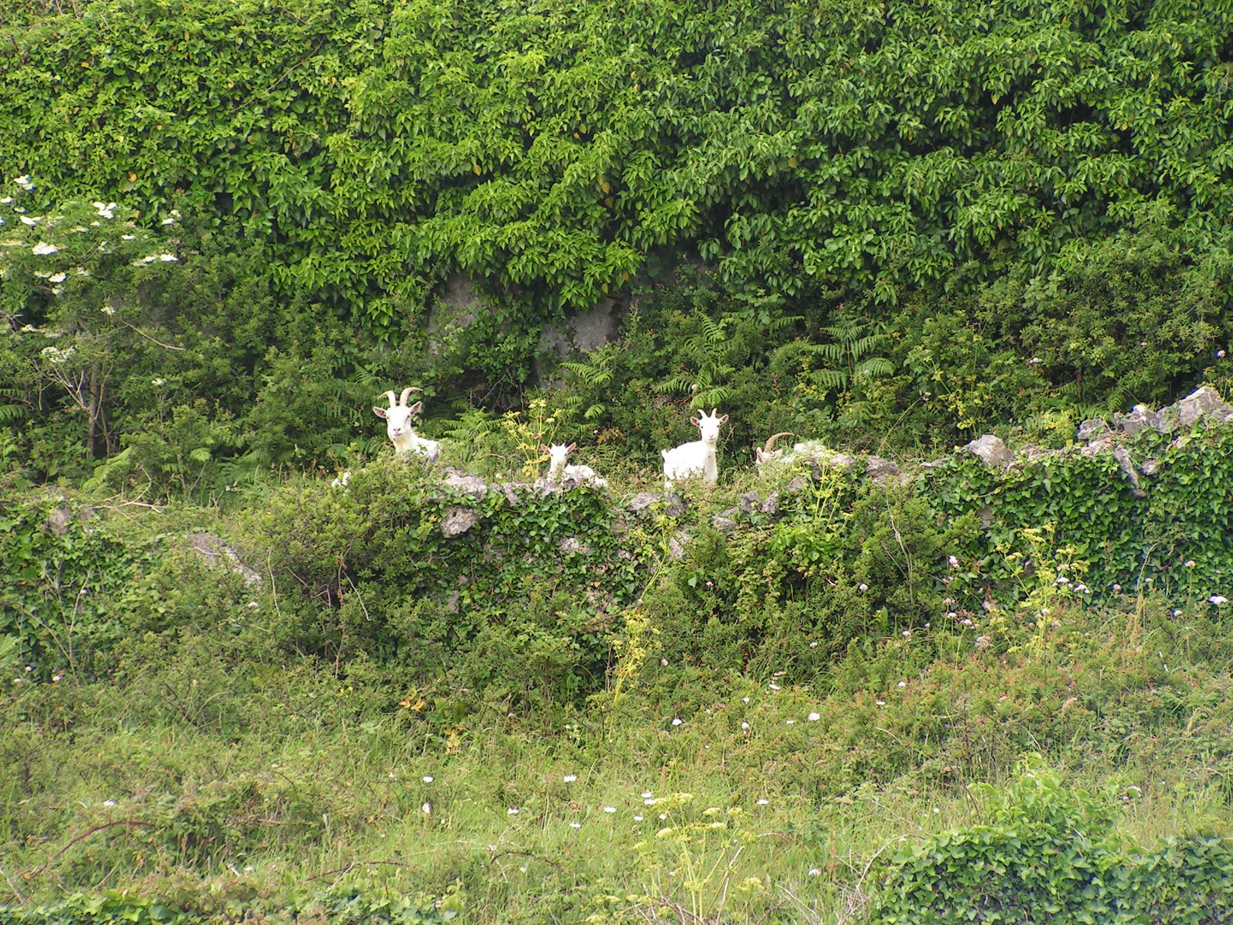
Figure 3: Goats grazing scrub on the Aran Islands.

Field survey methodology
Field relevé data
Botanical surveys were carried out between out between May and September 2016 and 2017 using national methodologies (O’Neill et al. 2013). The vascular plant species in 2m x 2 m quadrats at each scrub removal site (Fig. 1) were recorded and their cover estimated using percent cover (% Cover recorded instead of DOMIN– recommended by Irish Semi-natural grasslands survey final report for benefits associated with numerical analysis of metastudies.)
Transect data
Surveys were conducted on areas where there was recent scrub removal and a paired releve/transect in the main sward. Transects quadrats were placed one meter away from and parallel to encroached stone walls. Where possible, transects were located along walls to the south and southwest within a field. This was to minimize the potential of compounding variables.
Transects represented a sample and each 1x1m quadrat within represented a sub-sample. Sub samples within transects were aggregated by averaging of the midpoint of category classes Class width was kept as narrow as possible to improve the accuracy of average count and percent cover.
During the categorization of factors the following observations were made: Bracken occurred in the majority of quadrats. All spraying and recutting retreatments were carried out in summer, therefore, retreatment date is not specified as a factor.

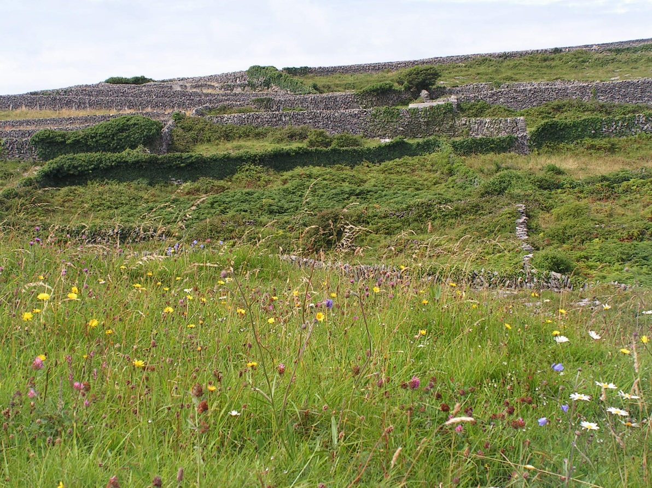
Figure 4: Scrub encroachment on the Aran Islands

Figure 5: Botanical sampling on the Aran Islands

Results & Discussion
The following pages report some trends in relation to scrub treatment and response. It should be noted that these trends are based on preliminary analysis of data, on a limited number of sites, over a short duration of time. The trends presented should thus not be treated as absolute results. Further information is available in the AranLIFE Best Practice Guide: Scrub management on the Aran Islands.
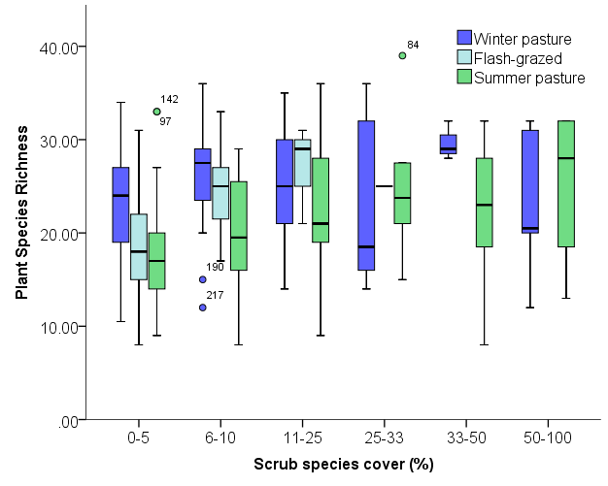
Figure 6: Scrub cover on the dominant grassland types of the Aran Islands
- On average, plant species richness decreased with increasing scrub cover on winter pasture

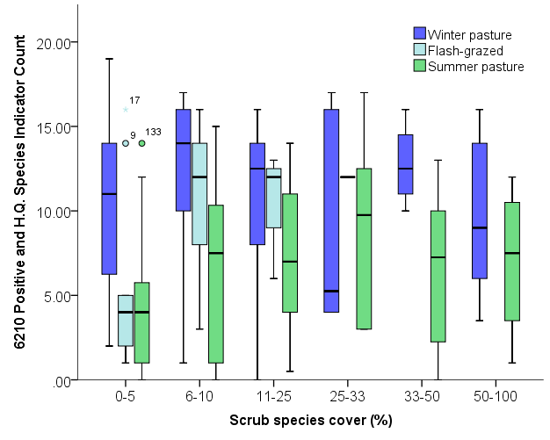
Figure 7: Association between scrub cover and the cover of high quality indicator species, across the main grassland management types of the Aran Islands
- Average count of positive and high quality indicator plant species decreased with increasing scrub cover on winter pasture

Impact of scrub control treatment on scrub species
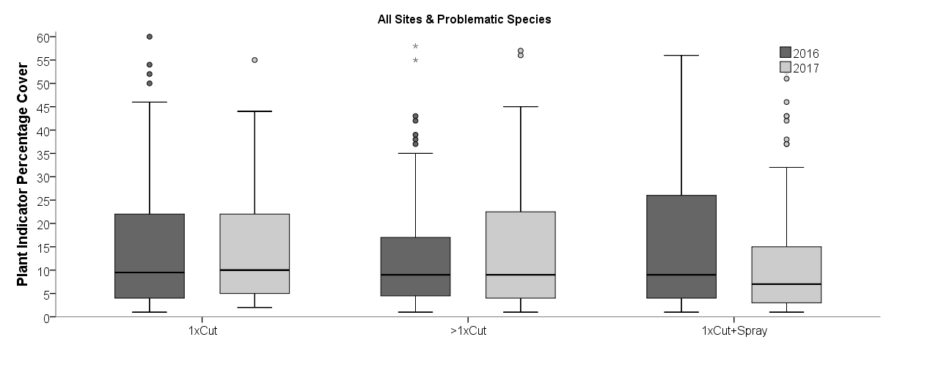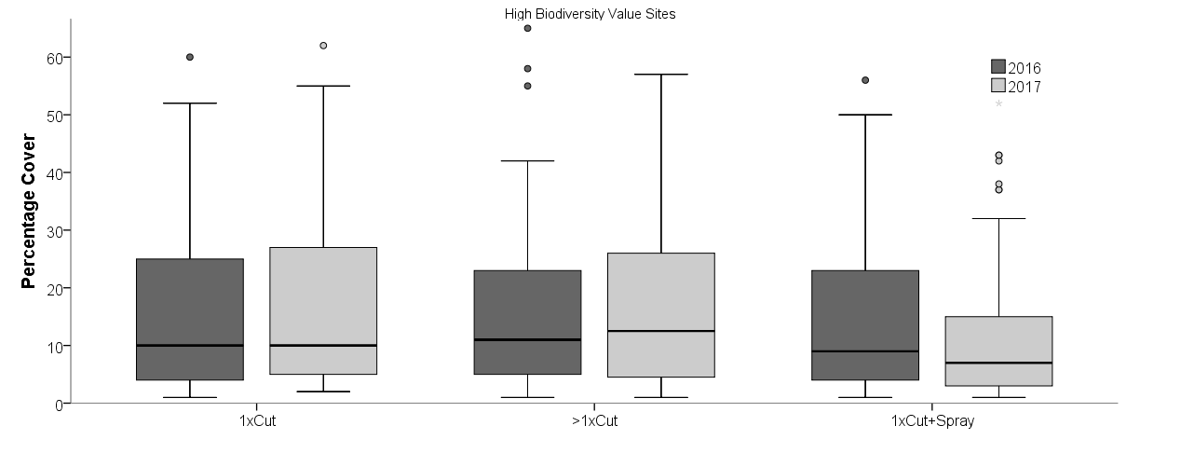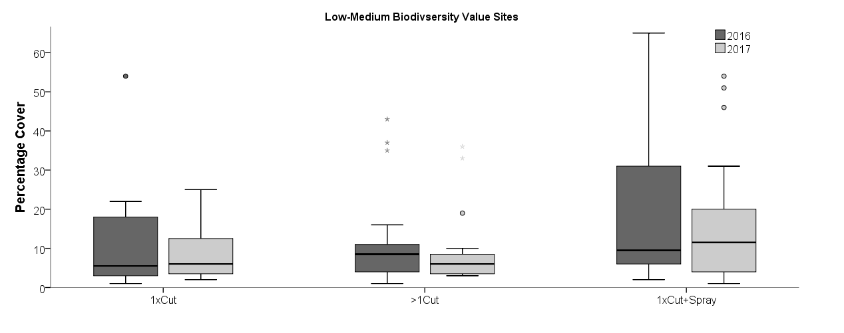
Figure 8. Response of scrub cover to scrub control treatment in a) all sites, b) plots adjacent to sites of high biodiversity value and c) plots adjacent to sites of low-moderate biodiversity value over two years

- Cut with herbicide treatment was slightly more effective as a scrub treatment in high biodiversity sites compared to single cut or repeat cutting.
- The opposite was true for sites with low-medium biodiversity, particularly in the second year of treatment, where these sites had higher scrub cover than sites which underwent a cutting or repeated cutting treatment.
Impact of scrub treatment on scrub type.
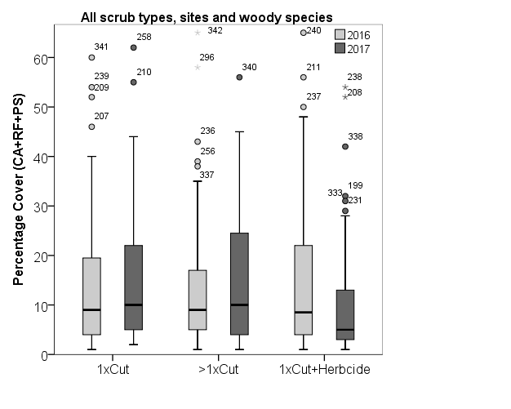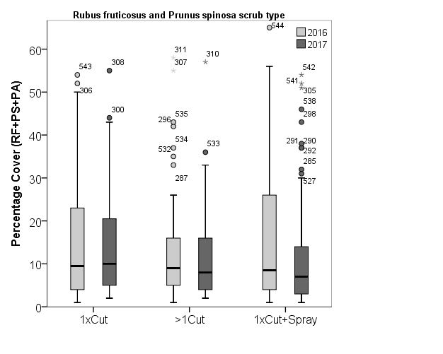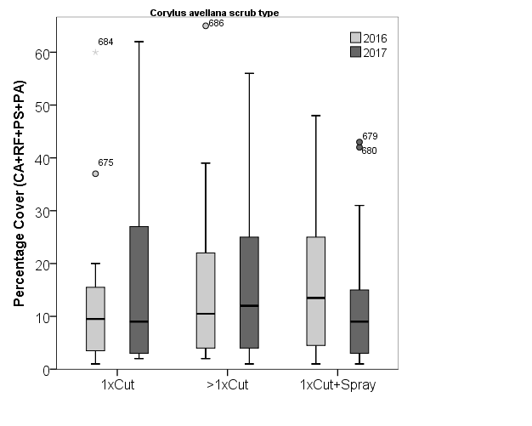
Figure 9: Response of cover of a) all scrub types, b) R. fruticosus and P. spinosa scrub and c) C. avellana scrub to scrub control treatment, over two years

- Sites with R. fruticosus and P. spinosa scrub had slightly lower scrub cover associated with the cut and herbicide treatment, compared to the single cut and repeat cutting treatments.
- Sites with C avellane scrub had slightly higher scrub cover associated with the cut and herbicide treatment in the first year, compared to the single cut and repeat cutting treatments; however this trend did not continue in the second year post-treatment.

Impact of scrub control treatment on botanical indicator species.

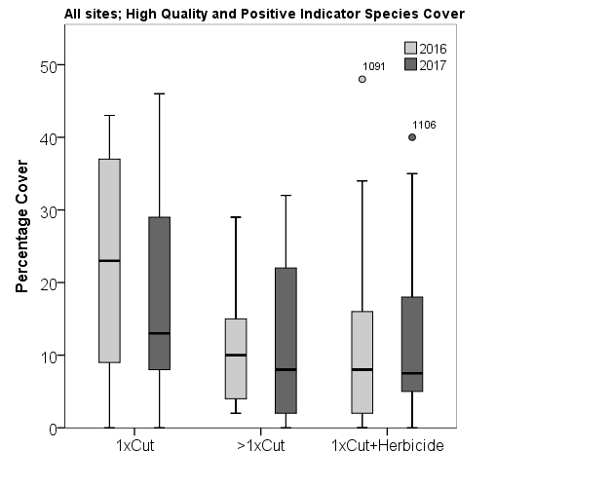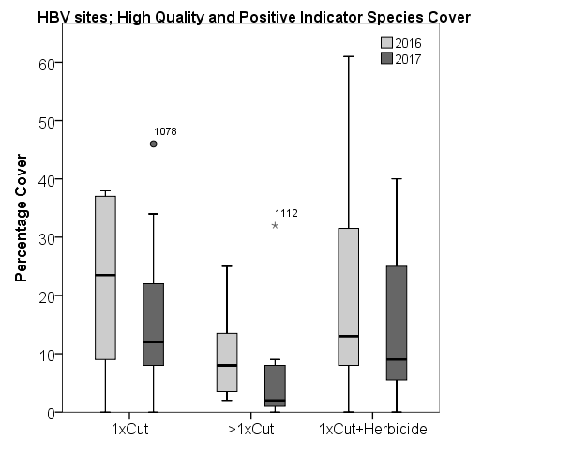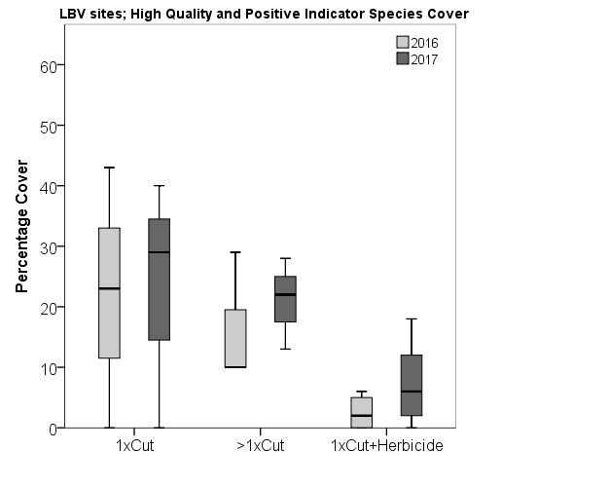
Figure 10: Impact of scrub control treatment on cover of high quality indicator species across a) all plots, b) plots within high biodiversity sites and c) plots within low biodiversity sites, over two years

- Sites treated with cutting and herbicide application had significantly less cover of high quality and positive indicator species, particularly in low biodiversity sites.
- Sites treated with a single cut of scrub had significantly higher cover of high quality and positive indicator species in the first year, however this trend was less apparent in the second year.

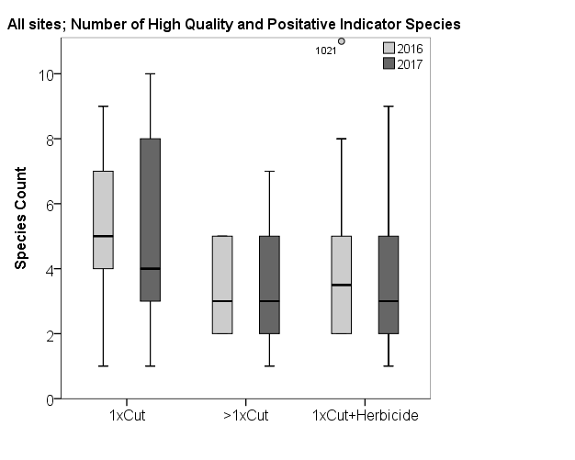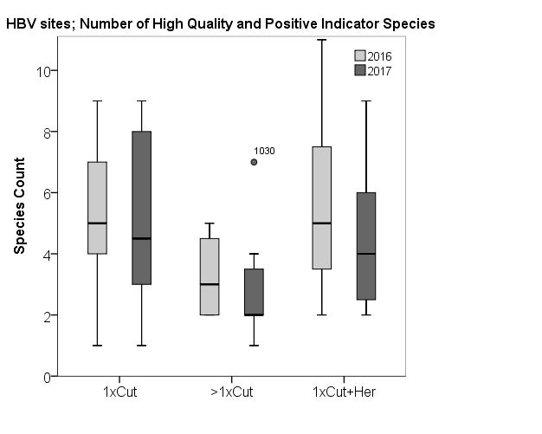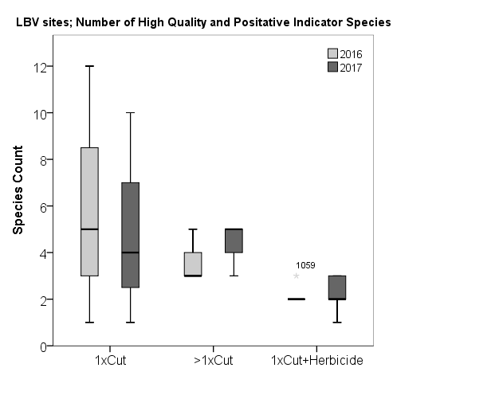
Figure 11: Impact of scrub control treatment on count of high quality indicator species across a) all plots, b) plots within high biodiversity sites and c) plots within low biodiversity sites, over two years

- Sites treated with cutting and herbicide application or repeated cutting had a significantly lower count of high quality and positive indicator species compared to sites subjected to a single cut.
- Sites treated with repeated cutting had the lowest count of high quality and positive indicator species in high biodiversity sites; whereas cutting and herbicide application had the lowest count for low biodiversity sites.
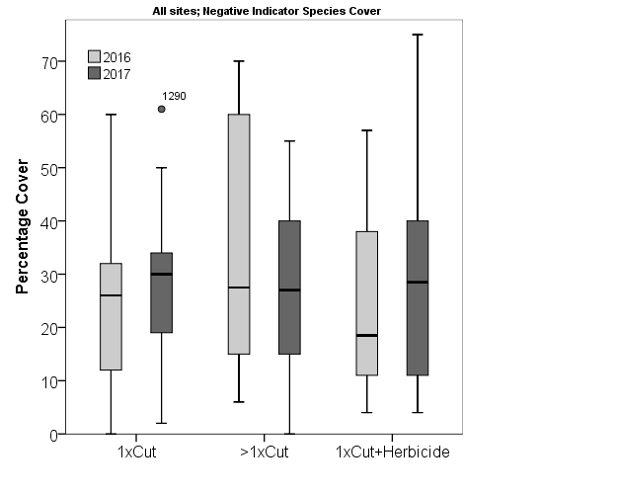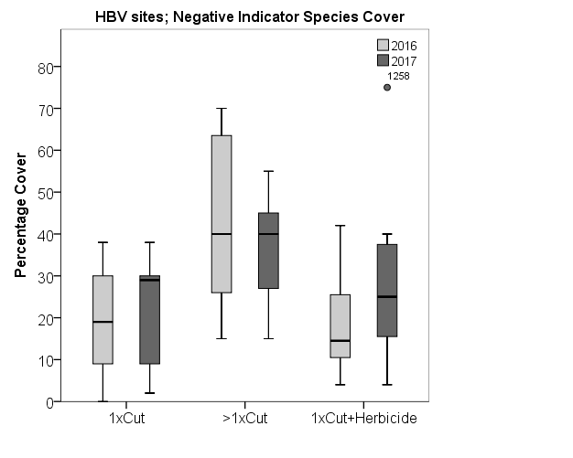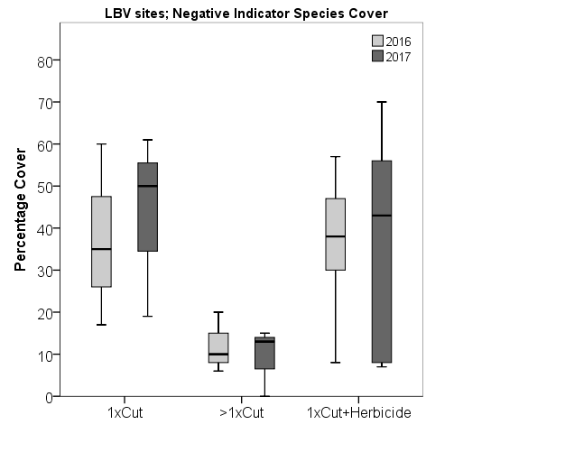
Figure 12: Impact of scrub control treatment on cover of negative indicator species across a) all plots, b) plots within high biodiversity sites and c) plots within low biodiversity sites, over two years

- There was little difference the cover of negative indicator species between the three scrub treatments in the second year of the application.
- Sites treated with repeated cutting had a higher cover of negative indicator species in high biodiversity sites. However, in low biodiversity sites, repeated cutting resulted in the lowest cover of negative indicator cover.

Sites divided by dominant scrub species
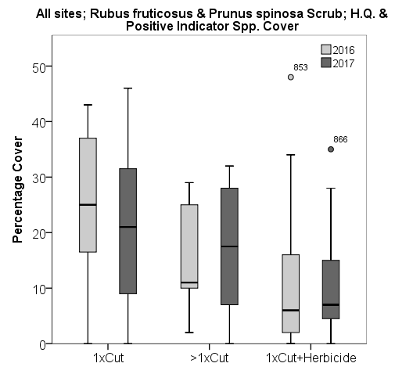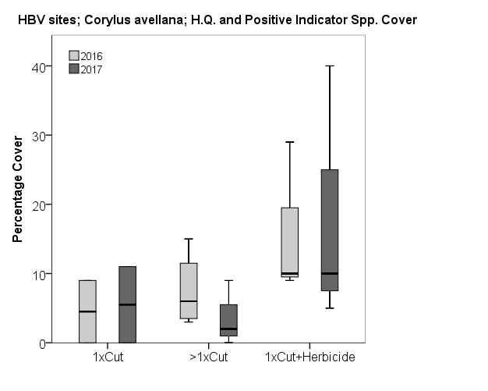
Figure 13: Impact of scrub control treatment on cover of positive indicator species, in a) R. fruticosus and P. spinosa and b) C. avellana dominated scrub, over two years.
- In sites dominated by R. fruticosus and P. spinosa scrub, cutting with herbicide application results in the lowest cover of high quality and positive indicator species.
- On the other-hand, in sites dominated by C avellana scrub, cutting with herbicide application resulted in the highest cover of high quality and positive indicator species.

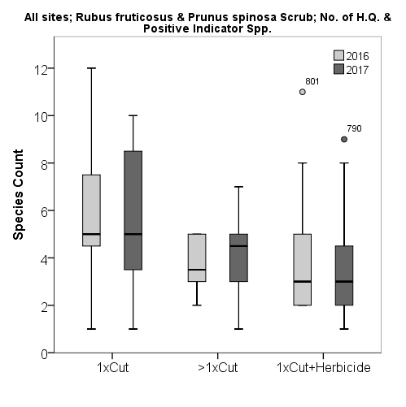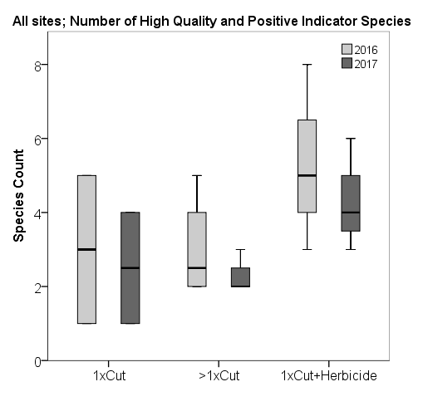
Figure 14: Impact of scrub control treatment on count of positive indicator species in a). R. fruticosus and P. spinosa dominated scrub and b) C. avellana scrub over two years.
- The results for Figure 14 followed a similar trend to those of Figure 13. In sites dominated by R. fruticosus and P. spinosa scrub, cutting with herbicide application results in the lowest count of high quality and positive indicator species.
- In sites dominated by C avellana scrub, cutting with herbicide application resulted in the highest cover of high quality and positive indicator species.

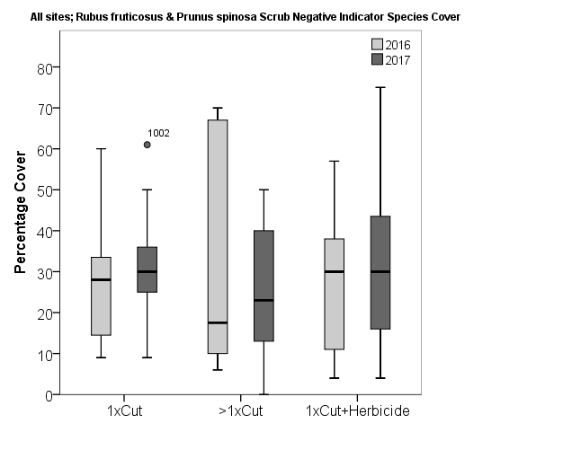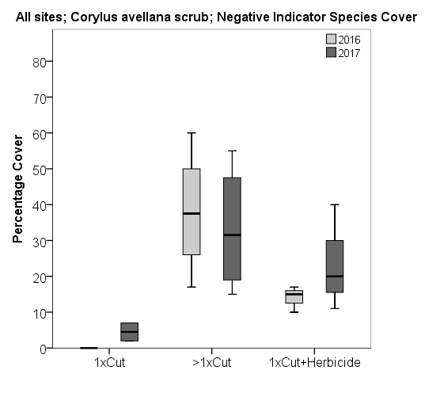
Figure 15: Impact of scrub control treatment on cover of negative indicator species in a) R. fruticosus and P. spinosa dominated scrub and b) C. avellana scrub over two years.

- In sites dominated by R. fruticosus and P. spinosa scrub, repeated cutting resulted in the lowest count of negative indicator species.
- In sites dominated by C avellana scrub, single cut resulted in significantly lower cover of negative indicator species that either of the other two treatments

Synopsis of results
There were significant variations in the response of scrub and indicator species to the three primary scrub treatment methodologies.
Single Cut
- Sites treated with a single cut of scrub had significantly higher cover of high quality and positive indicator species in the first year, however this trend was less apparent in the second year.
- In sites dominated by C avellana scrub, single cut resulted in significantly lower cover of negative indicator species that either of the other two treatments
Repeated cutting
- Sites treated with repeated cutting had the lowest count of high quality and positive indicator species and the highest cover of negative indicator species in high biodiversity sites.
- In low biodiversity sites and in sites dominated by R. fruticosus and P. spinosa scrub, repeated cutting resulted in the lowest cover of negative indicator cover.
Cutting and Herbicide treatment
- Cutting with herbicide treatment was slightly more effective as a scrub treatment in high biodiversity sites compared to single cut or repeat cutting. The opposite was true for sites with low-medium biodiversity, particularly in the second year of treatment, where these sites had higher scrub cover than sites which underwent a cutting or repeated cutting treatment.
- Sites treated with cutting and herbicide application had significantly lower cover and count of high quality and positive indicator species, particularly in low biodiversity sites.
- Sites with C avellane scrub had slightly higher scrub cover associated with the cut and herbicide treatment in the first year. These sites also had the highest cover and count of high quality and positive indicator species.
- Sites with R. fruticosus and P. spinosa scrub had slightly lower scrub cover associated with the cut and herbicide treatment, compared to the single cut and repeat cutting treatments. However these sites also had the lowest cover and count of high quality and positive indicator species.

For further Discussions and Recommendations, see the AranLIFE Best Practice Guide: Scrub management on the Aran Islands

